]
Finishing Information: | 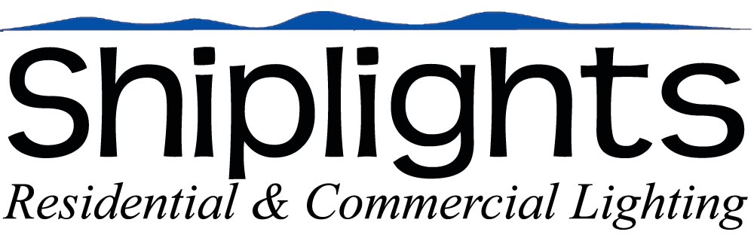

Standard Finishes: (Unlacquered Brass & Chrome)
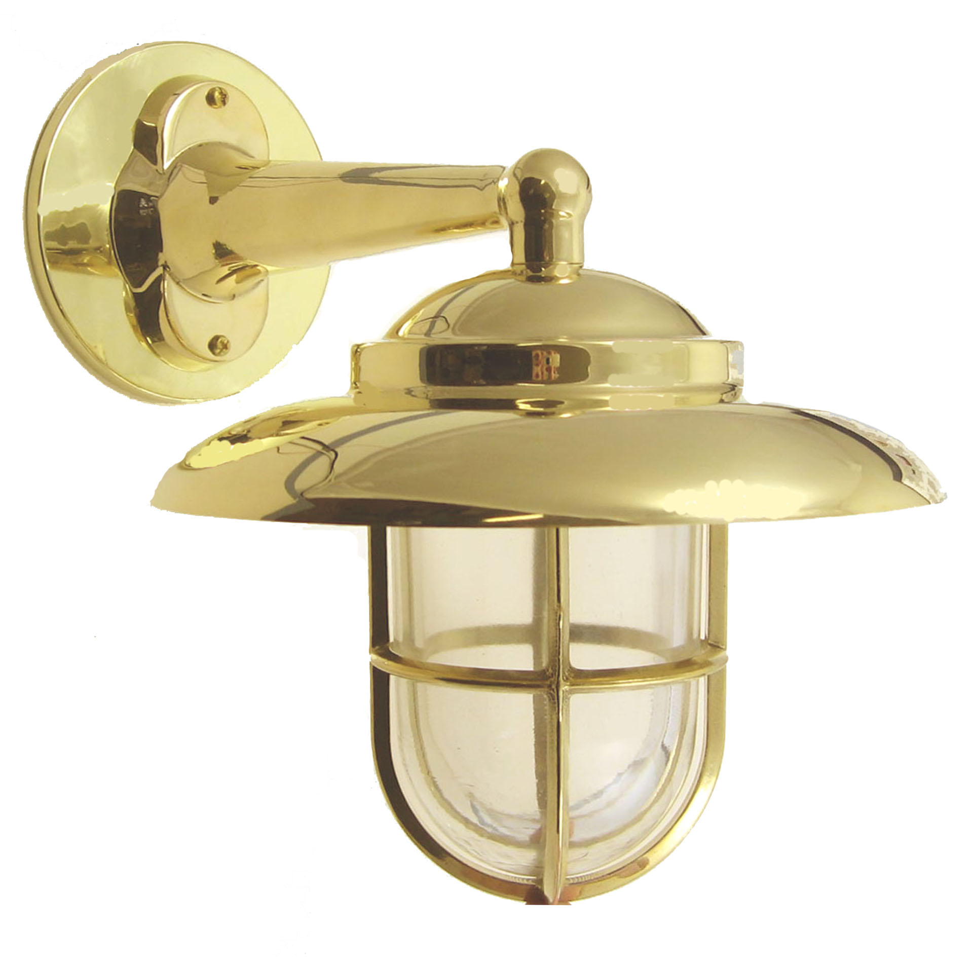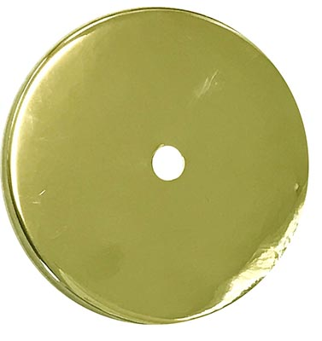  Unlacquered Brass  (will patina over time) | 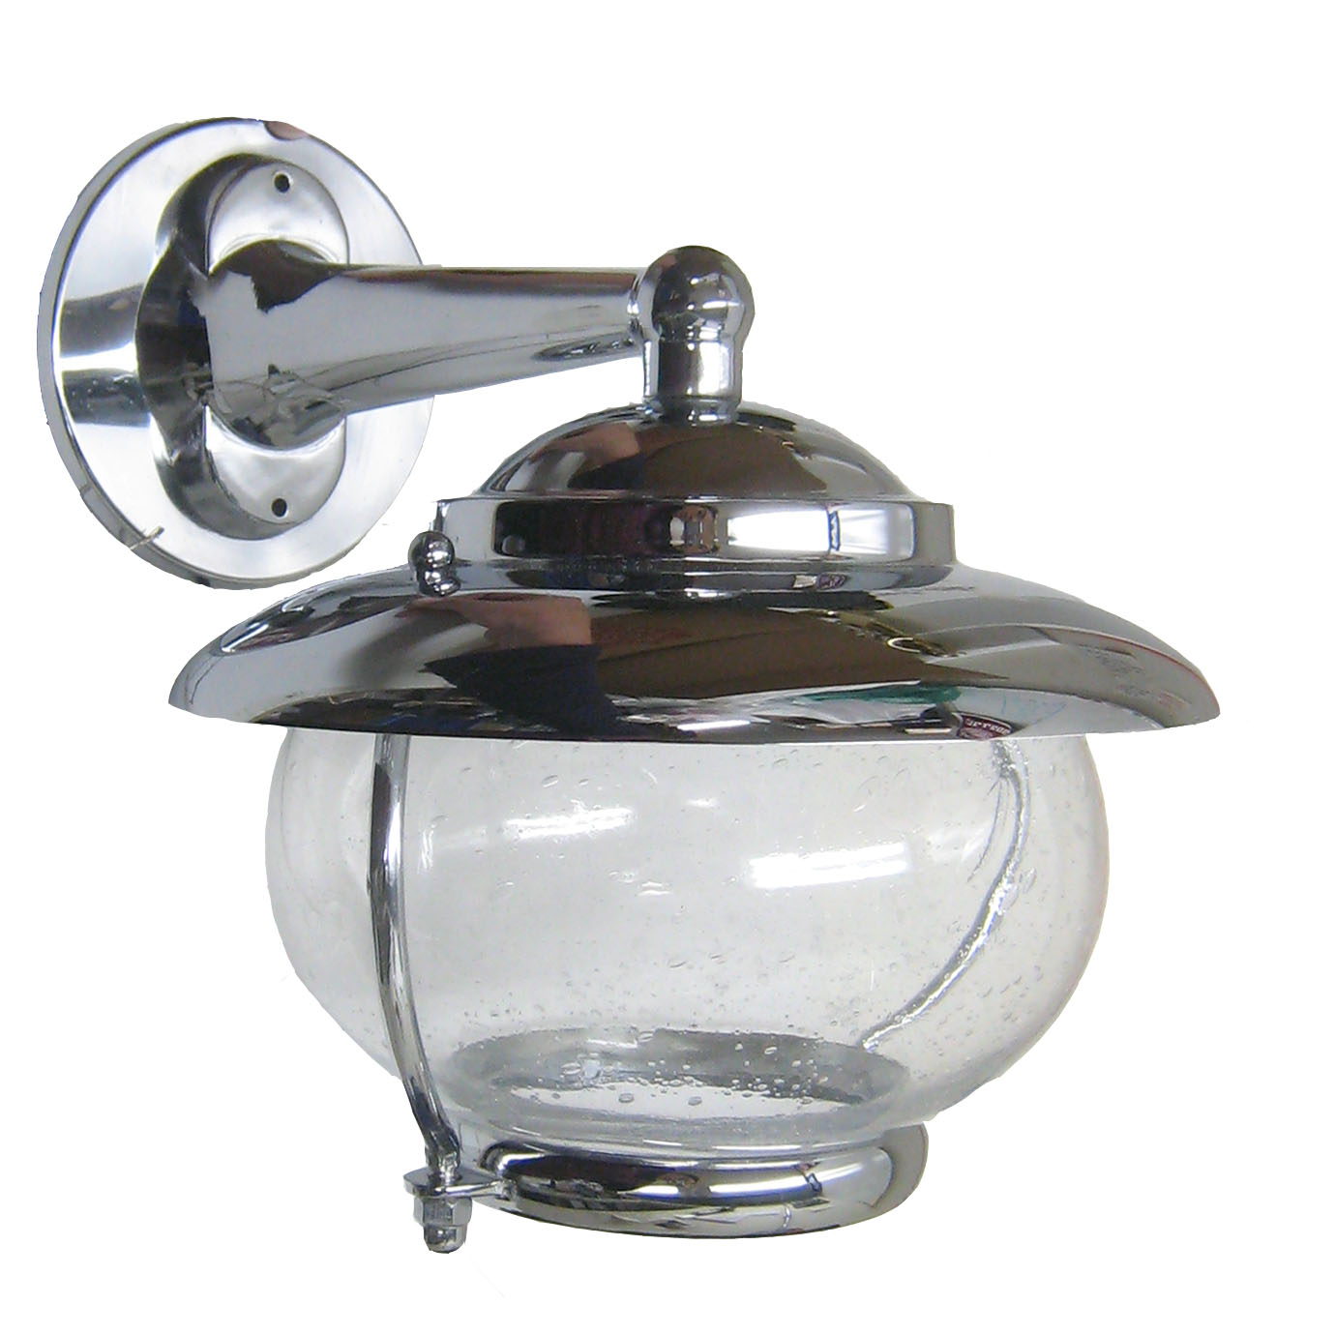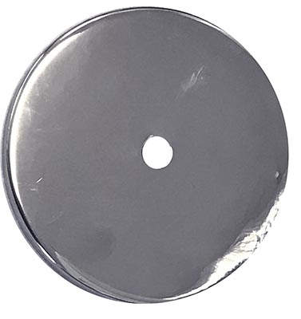  Chrome

Custom Finishes:

Brass & Copper Tones:

Antique Brass: Dark with brass tones though-out. Overall darkness will vary by batch.

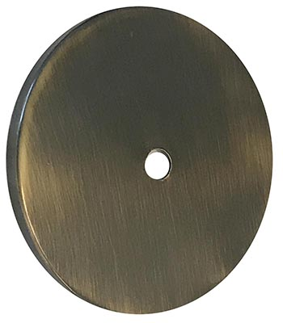 | 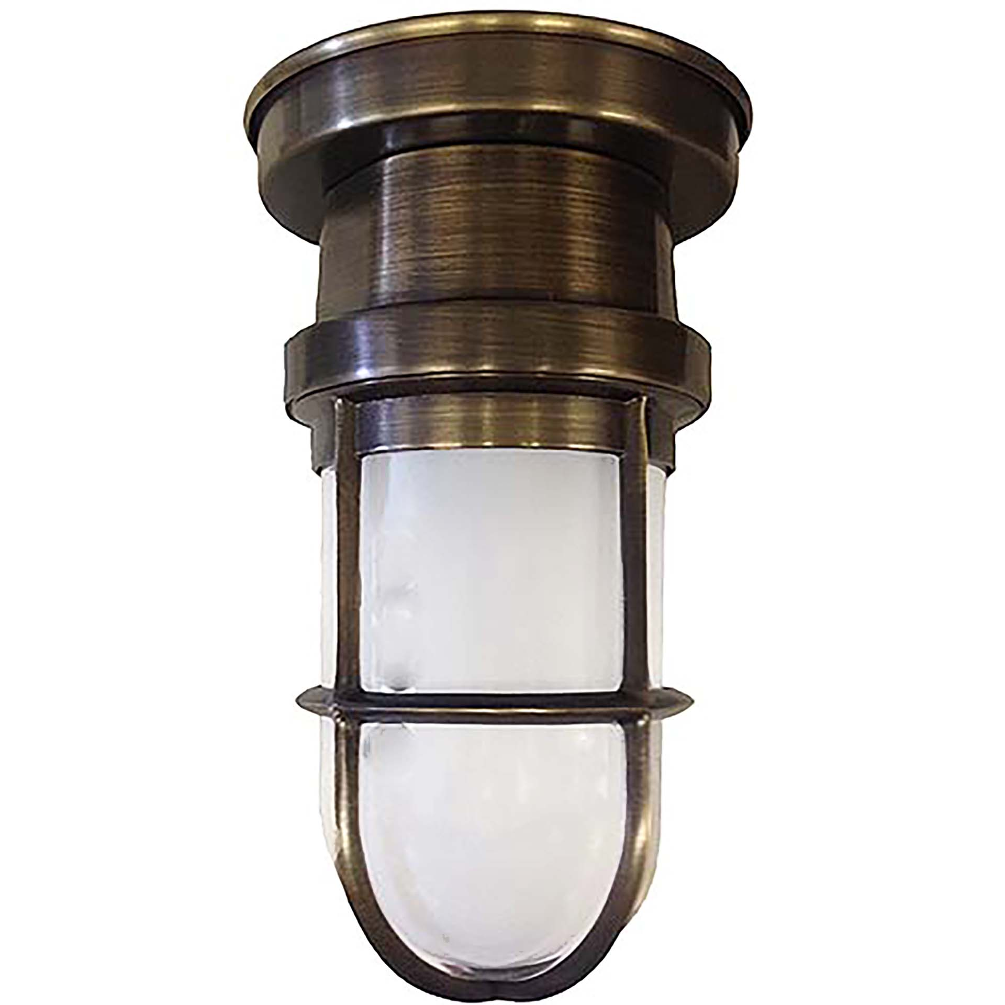 | 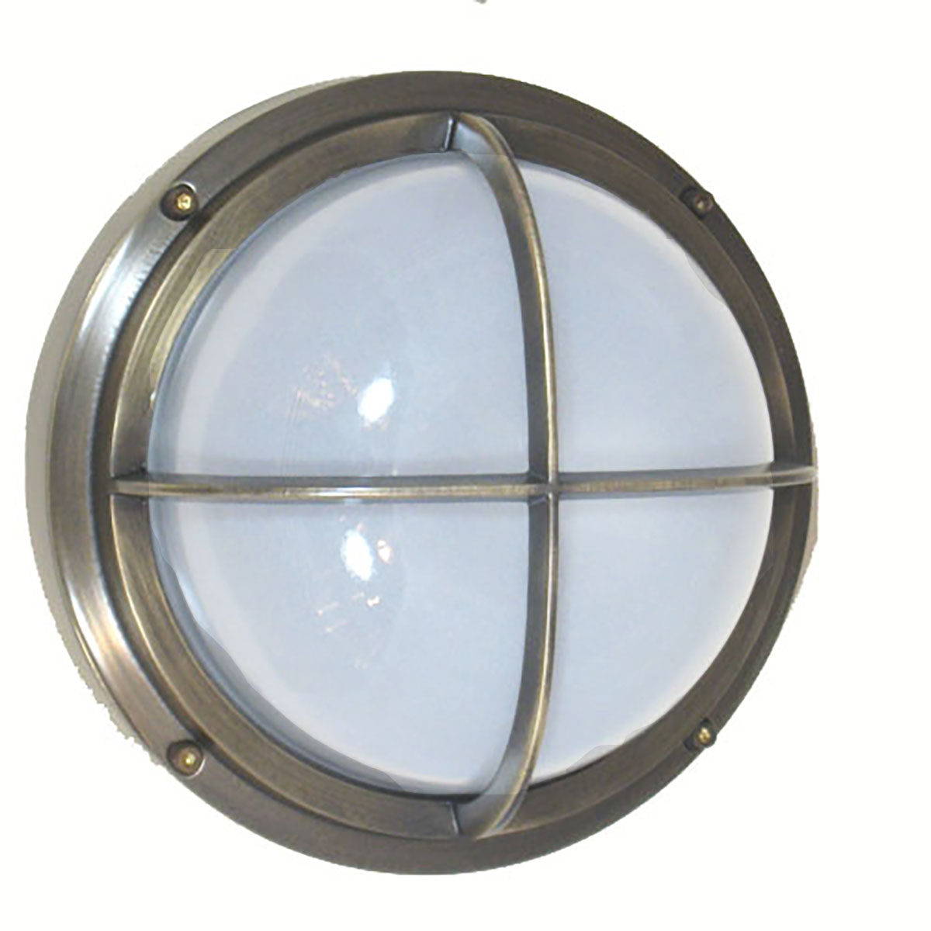 | 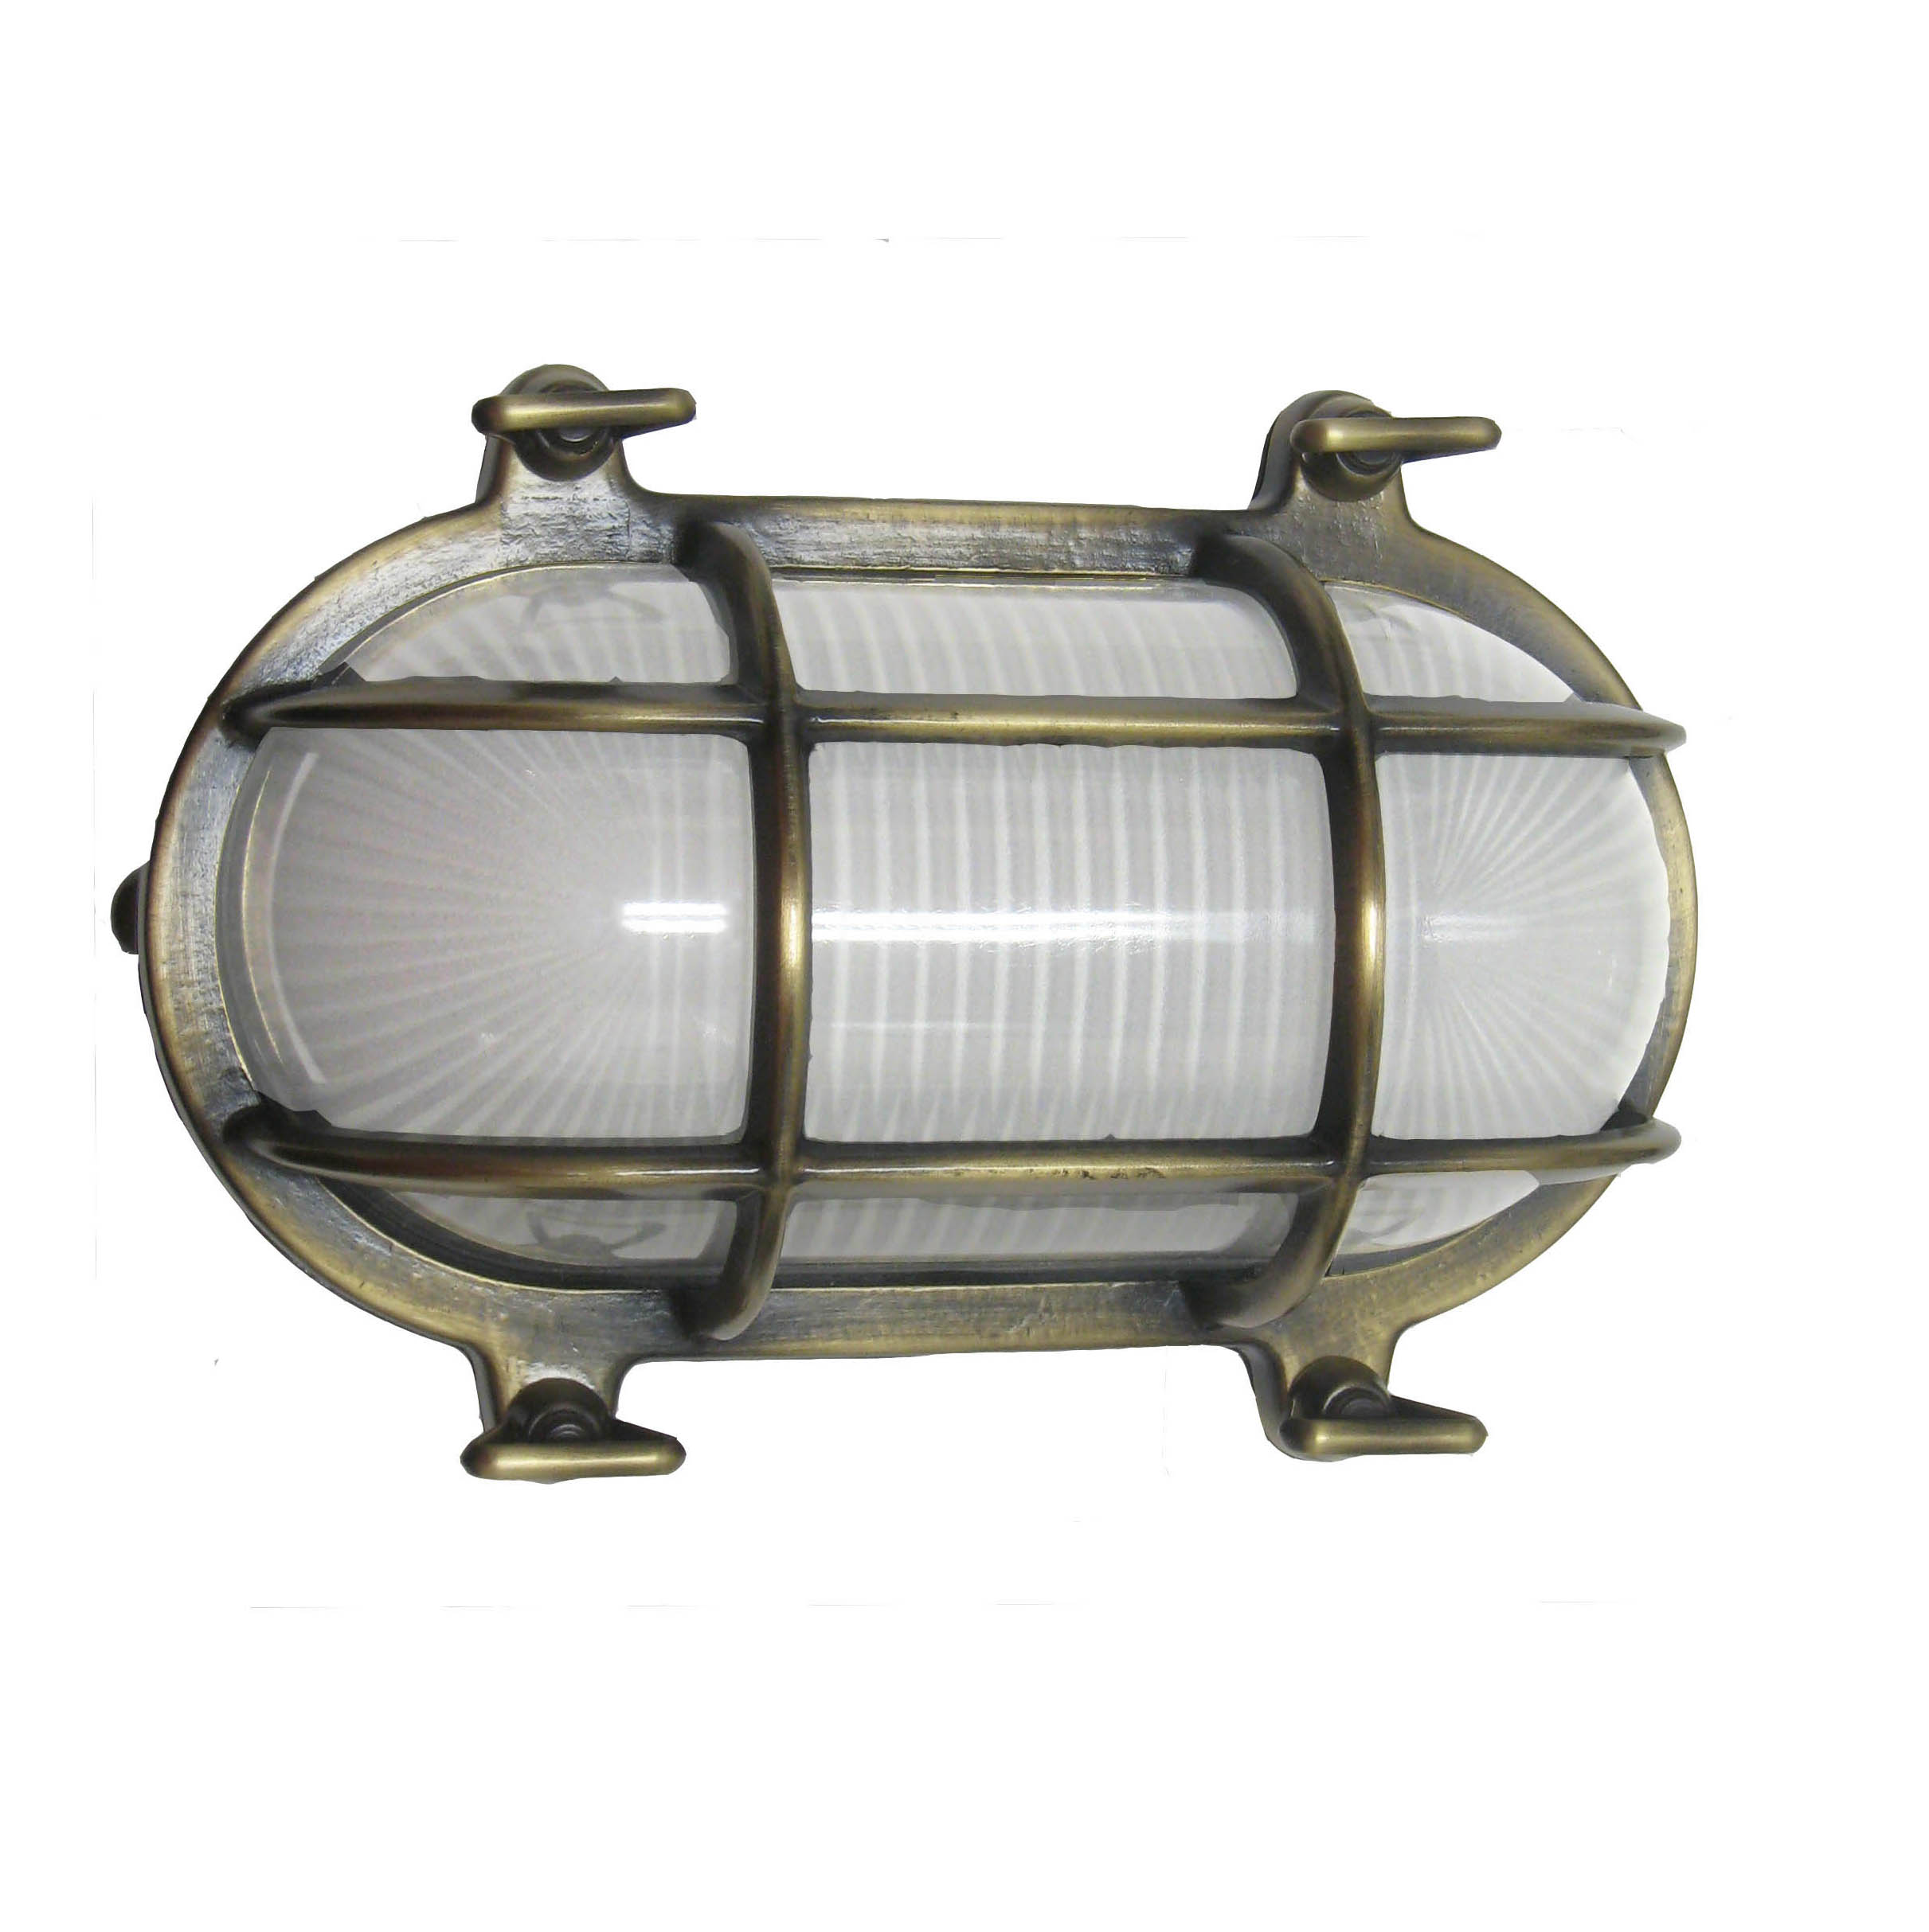
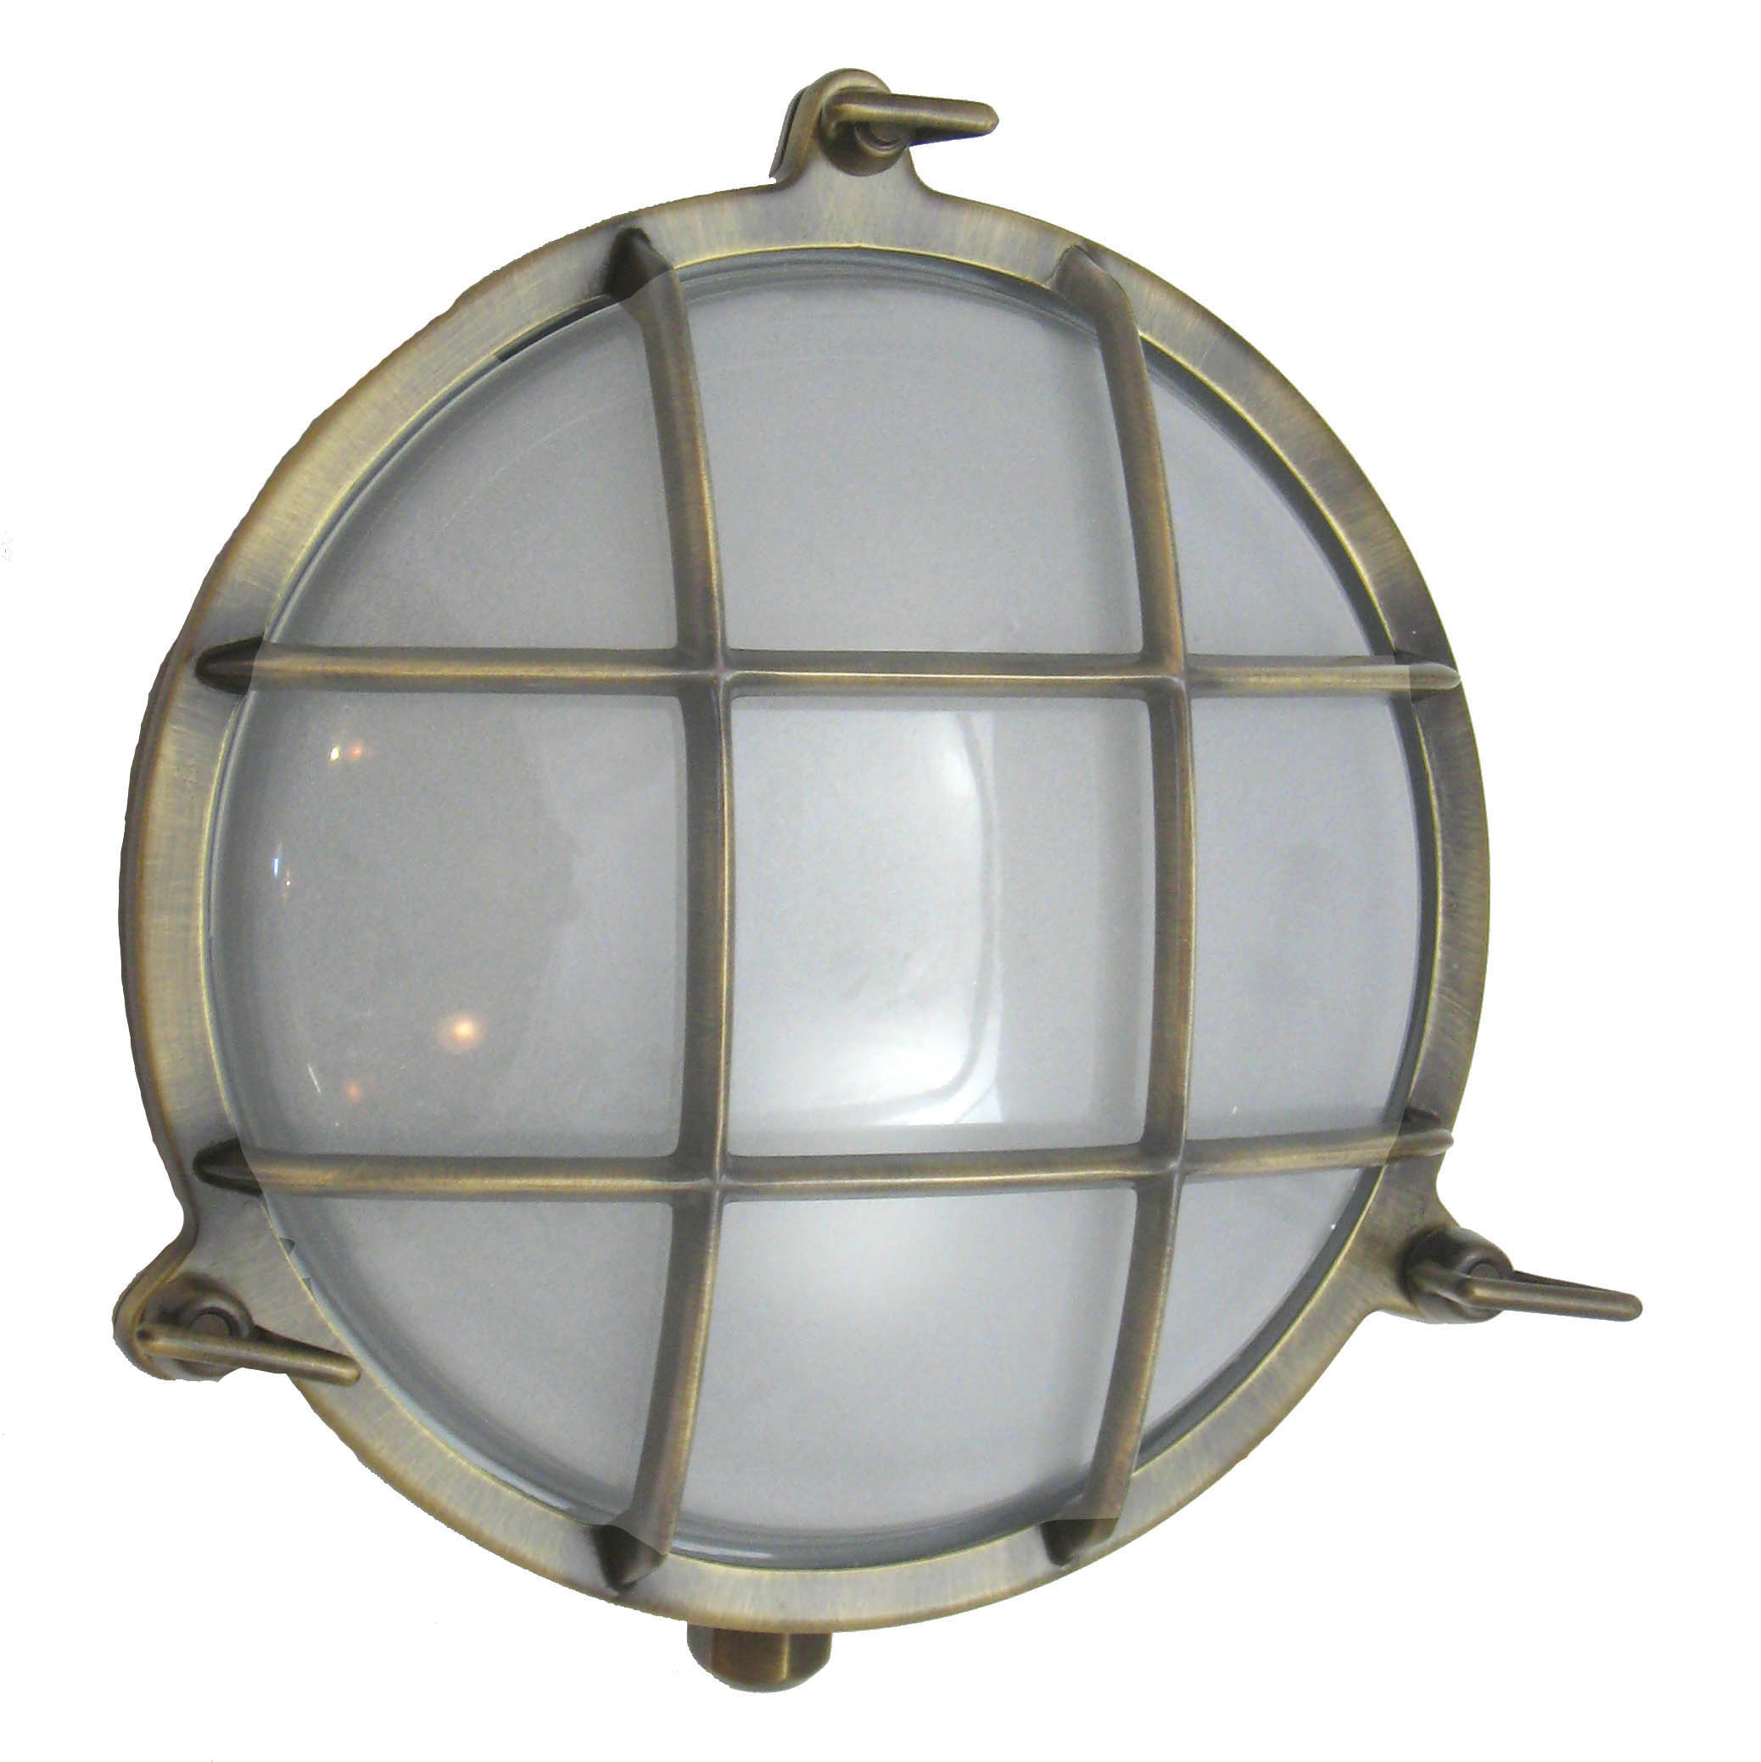 | 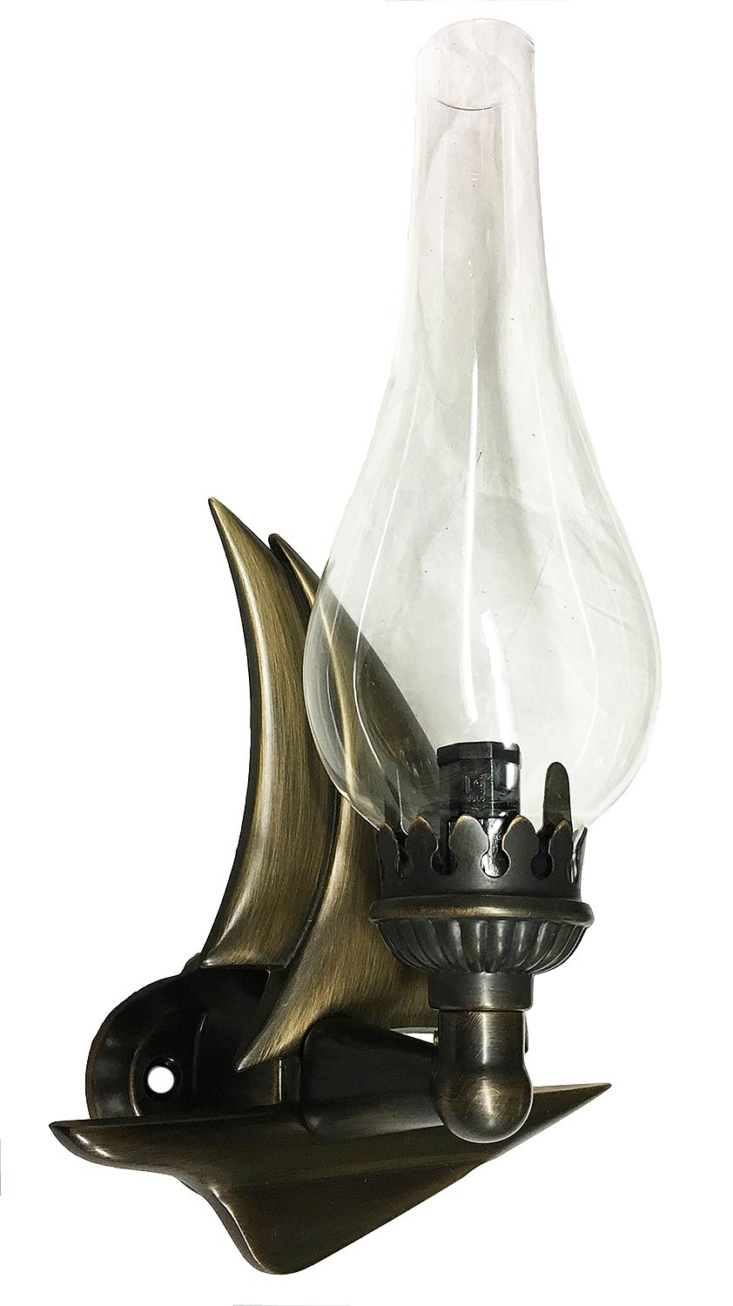

Lacquered Brass: To Only be used indoors or in less harsh Environments. Not recommended for exterior use by the Ocean.

Satin Brass: Available Lacquered and Unlacquered, the finish has a brushed look to it.

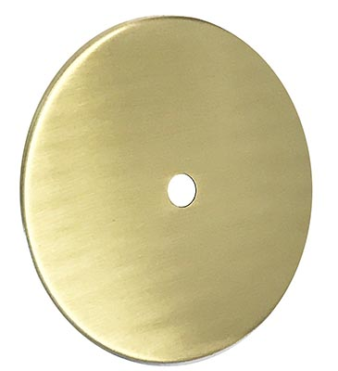 | 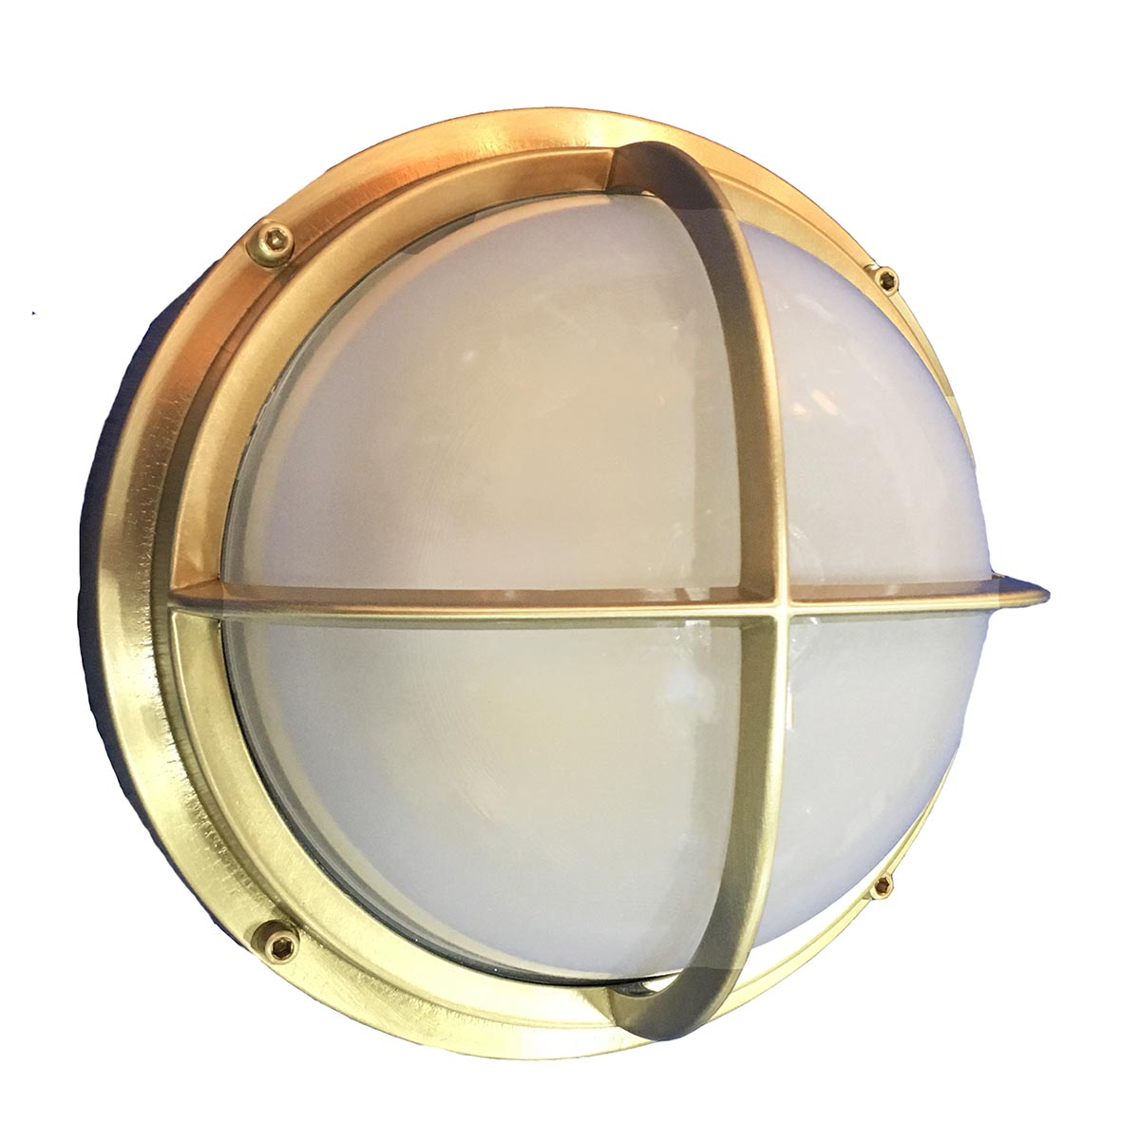

Oil Rubbed Bronze: Finish varies between a more brown color and a more black color – This living finish will continue to darken over time and eventually Verdigris when used in any harsh environment.

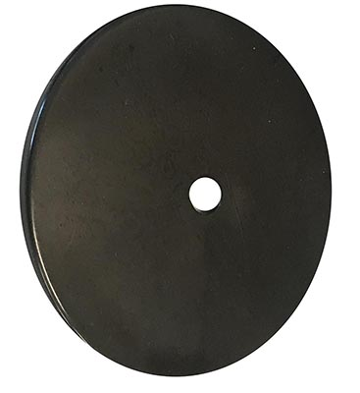 | 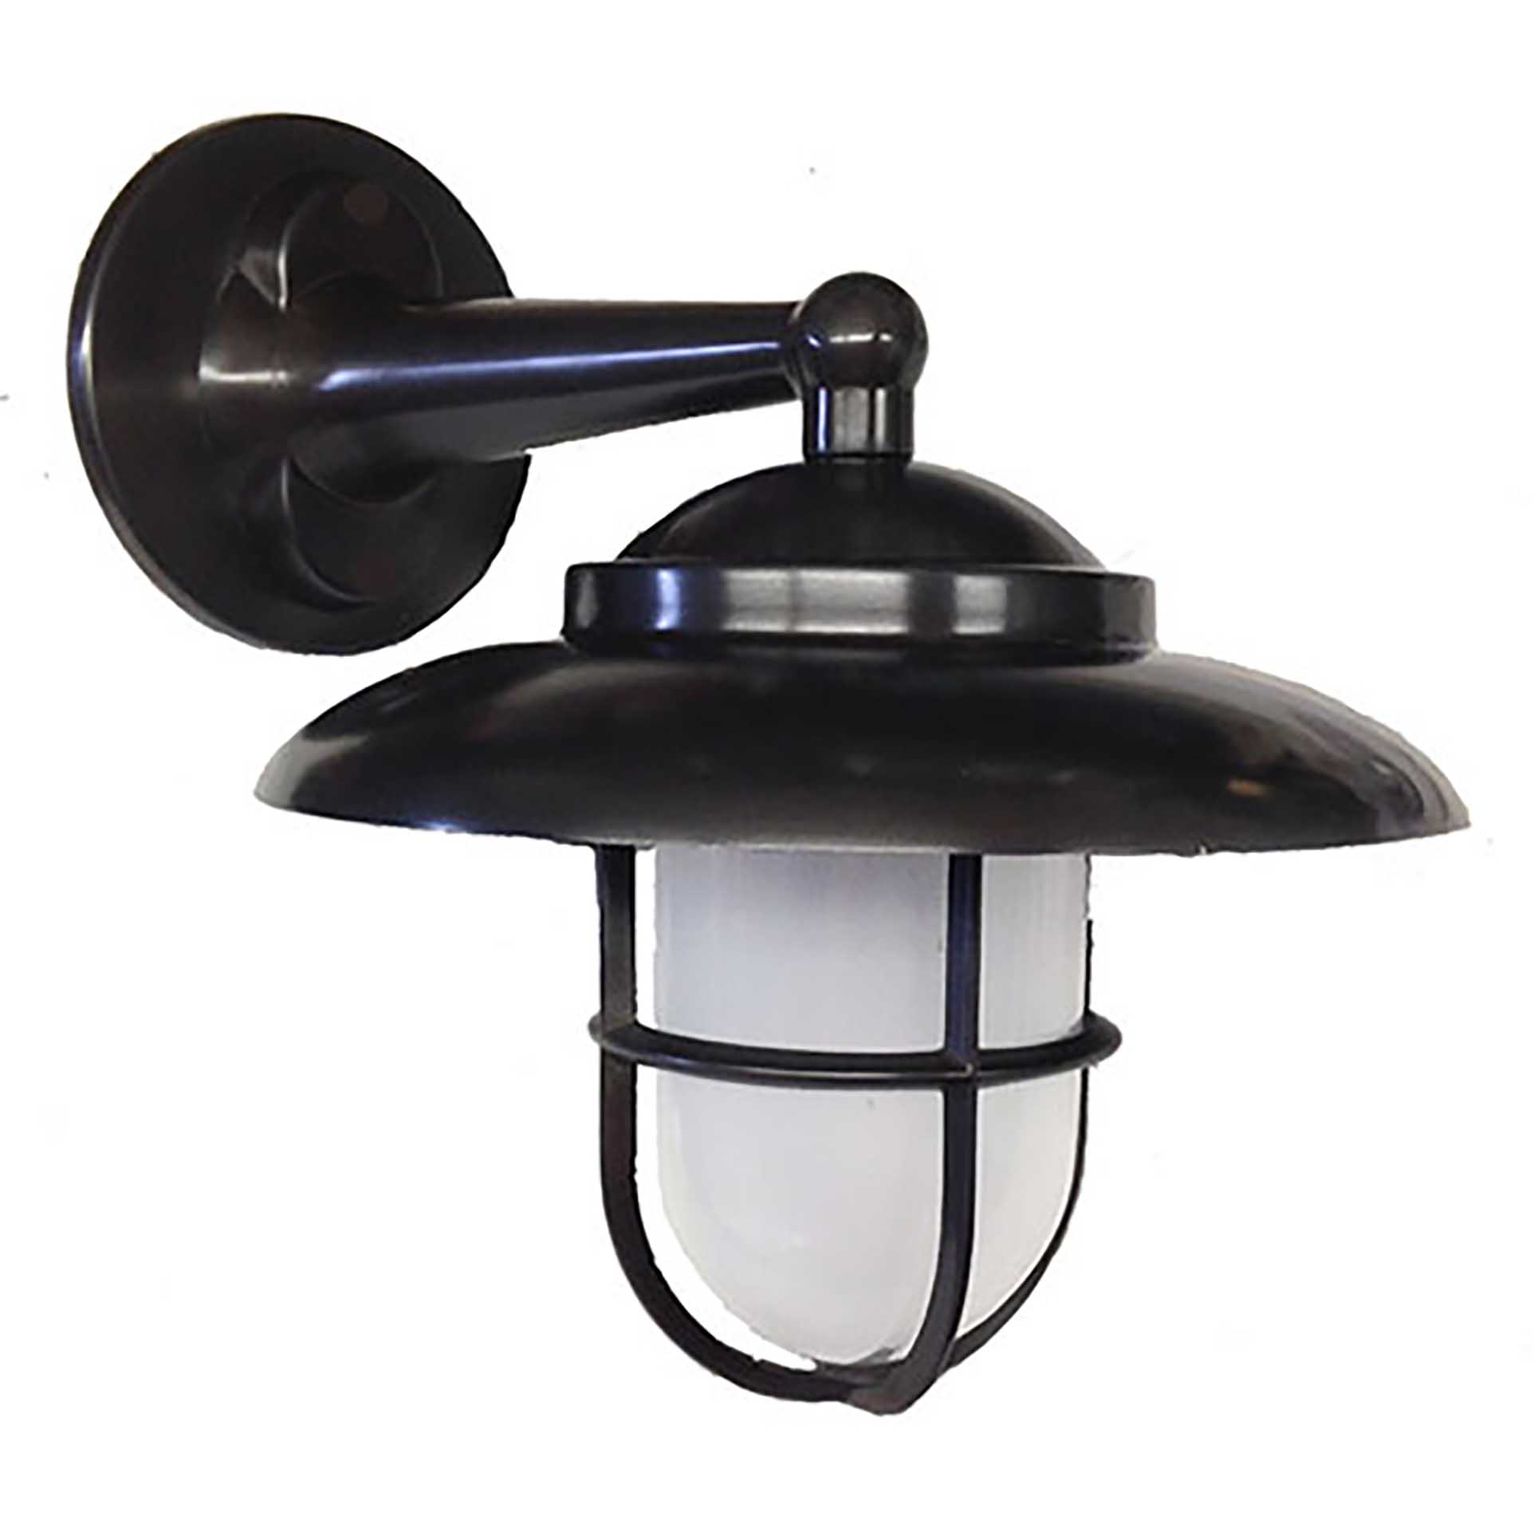 | 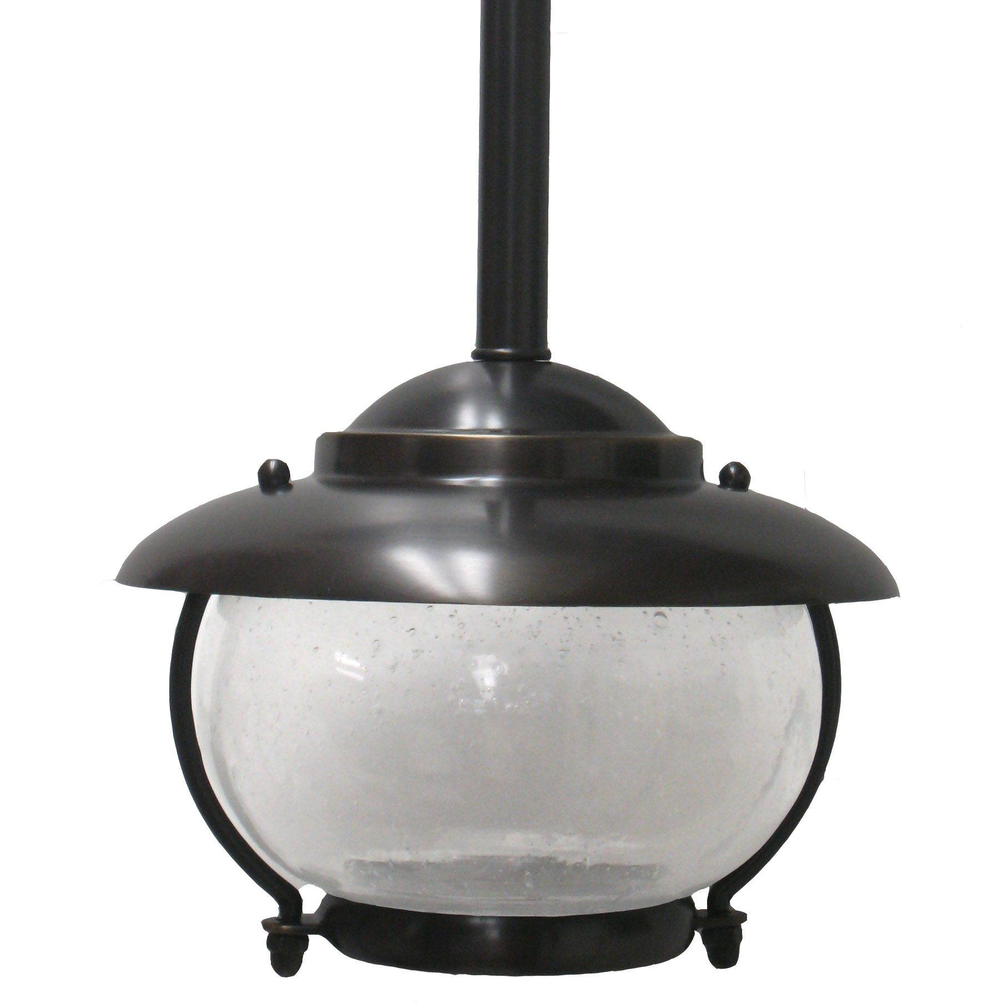 | 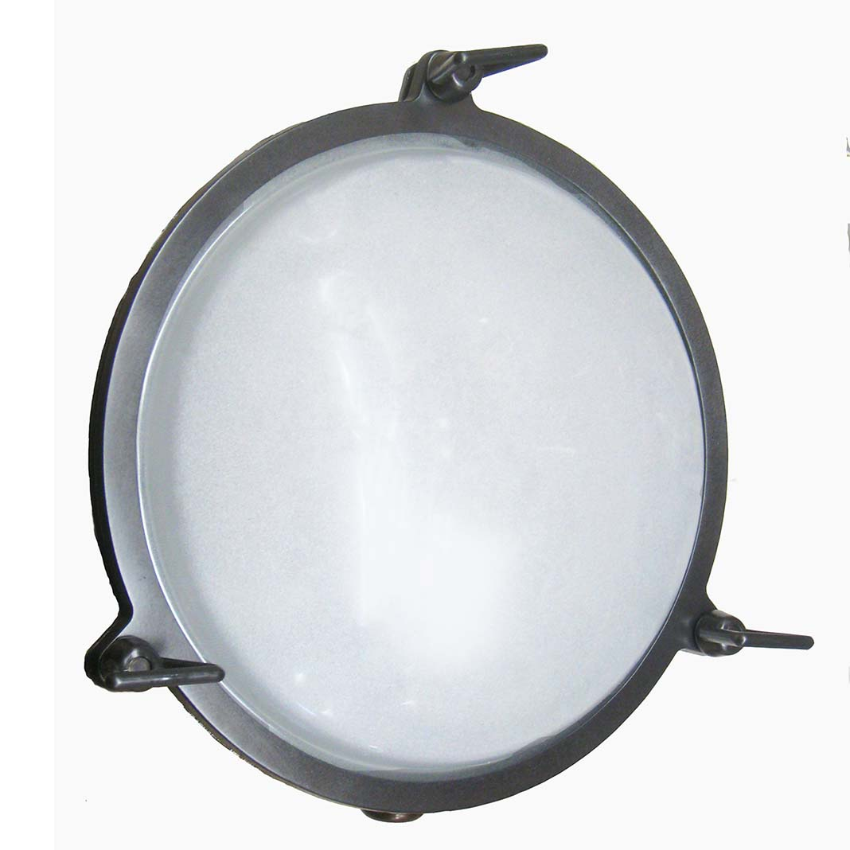
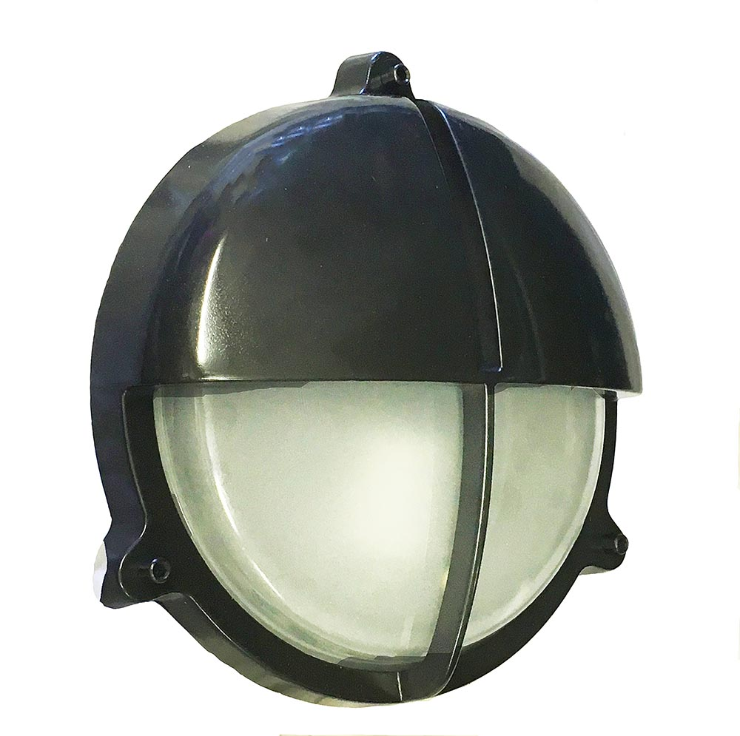 | 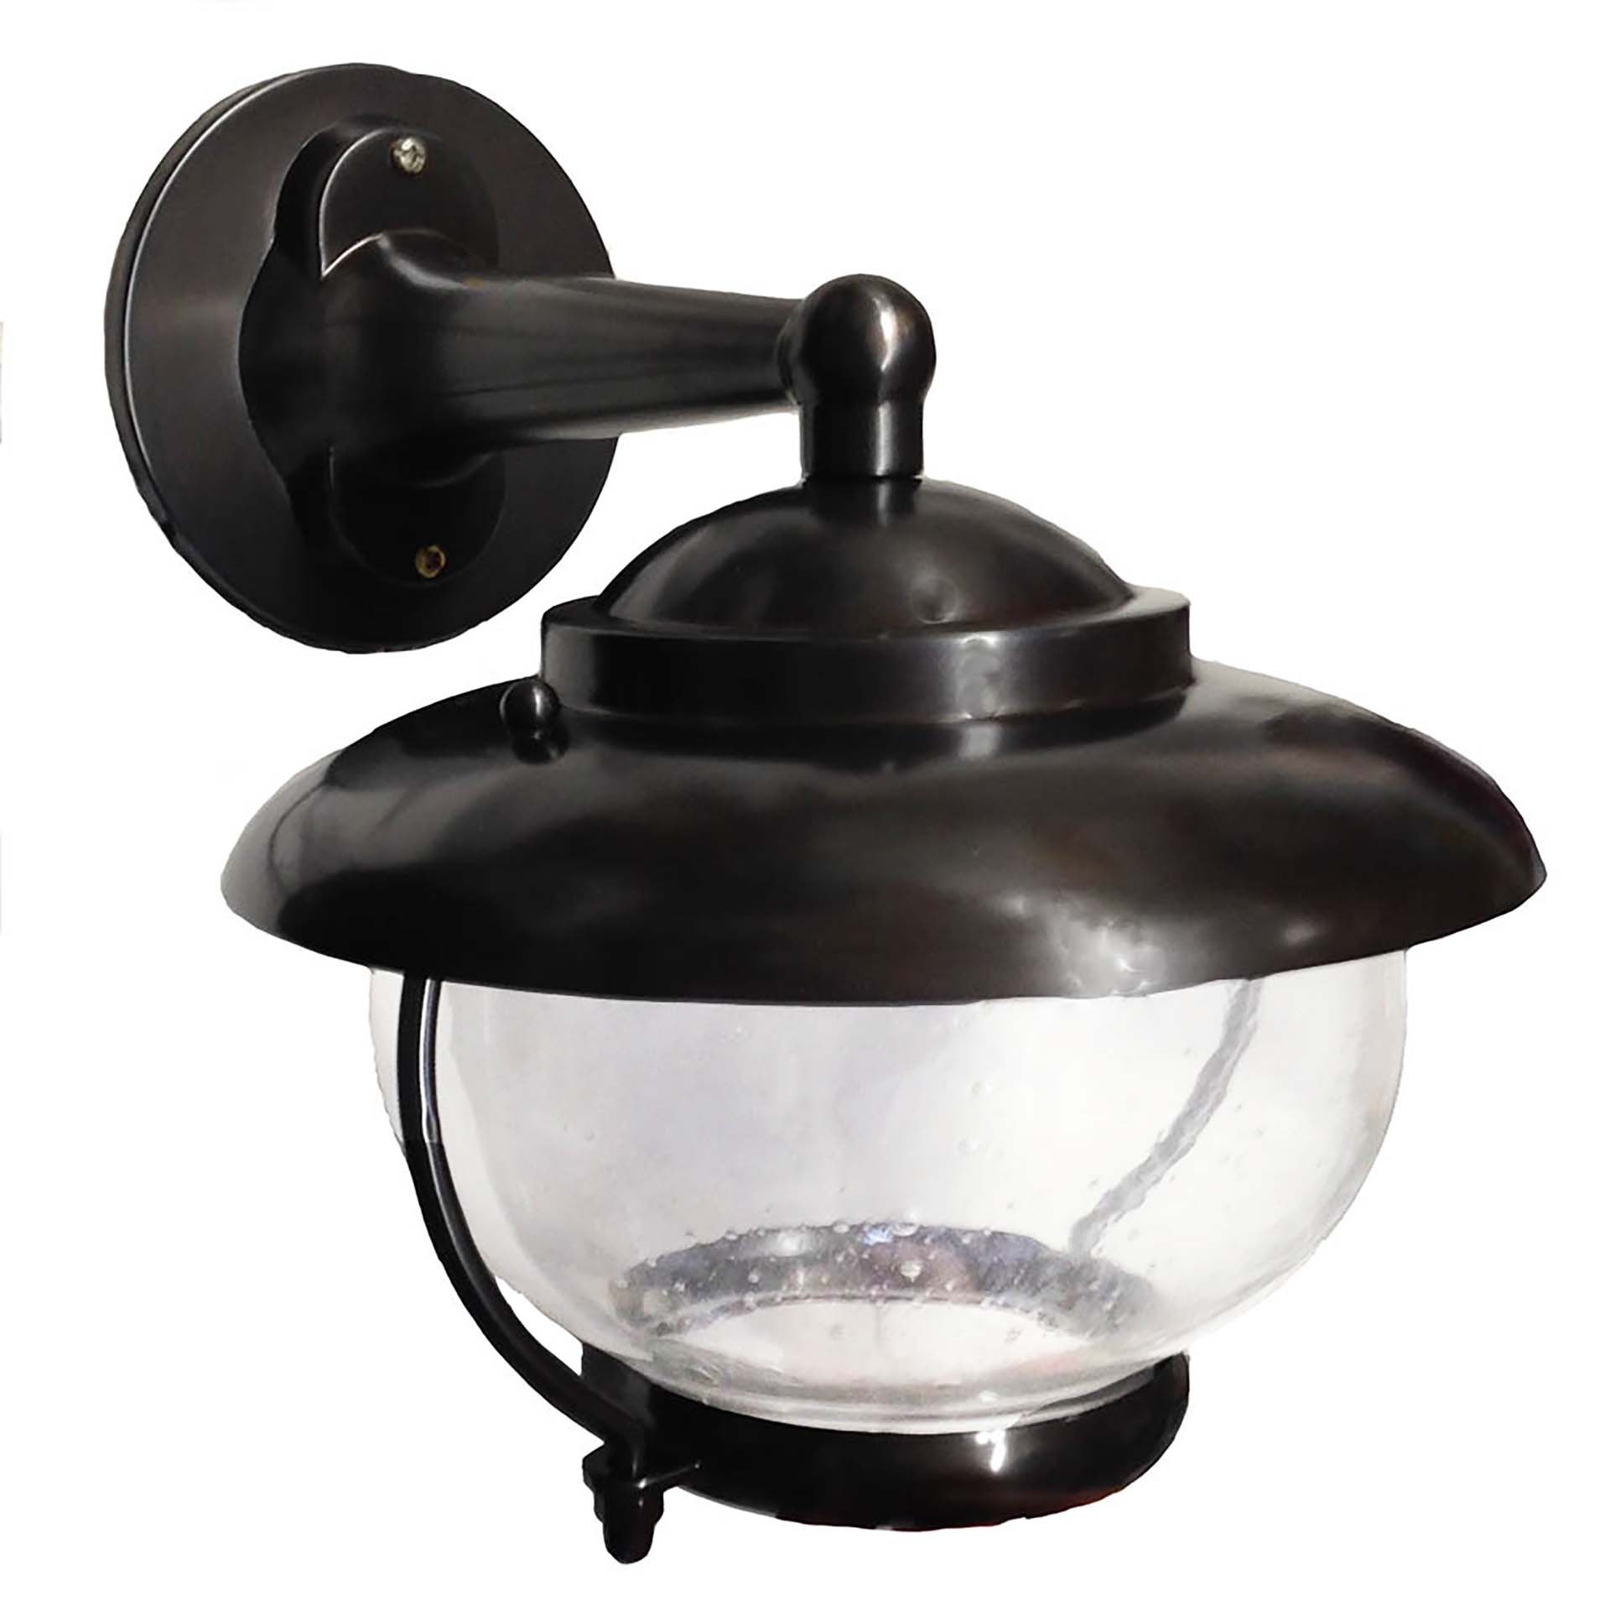 | 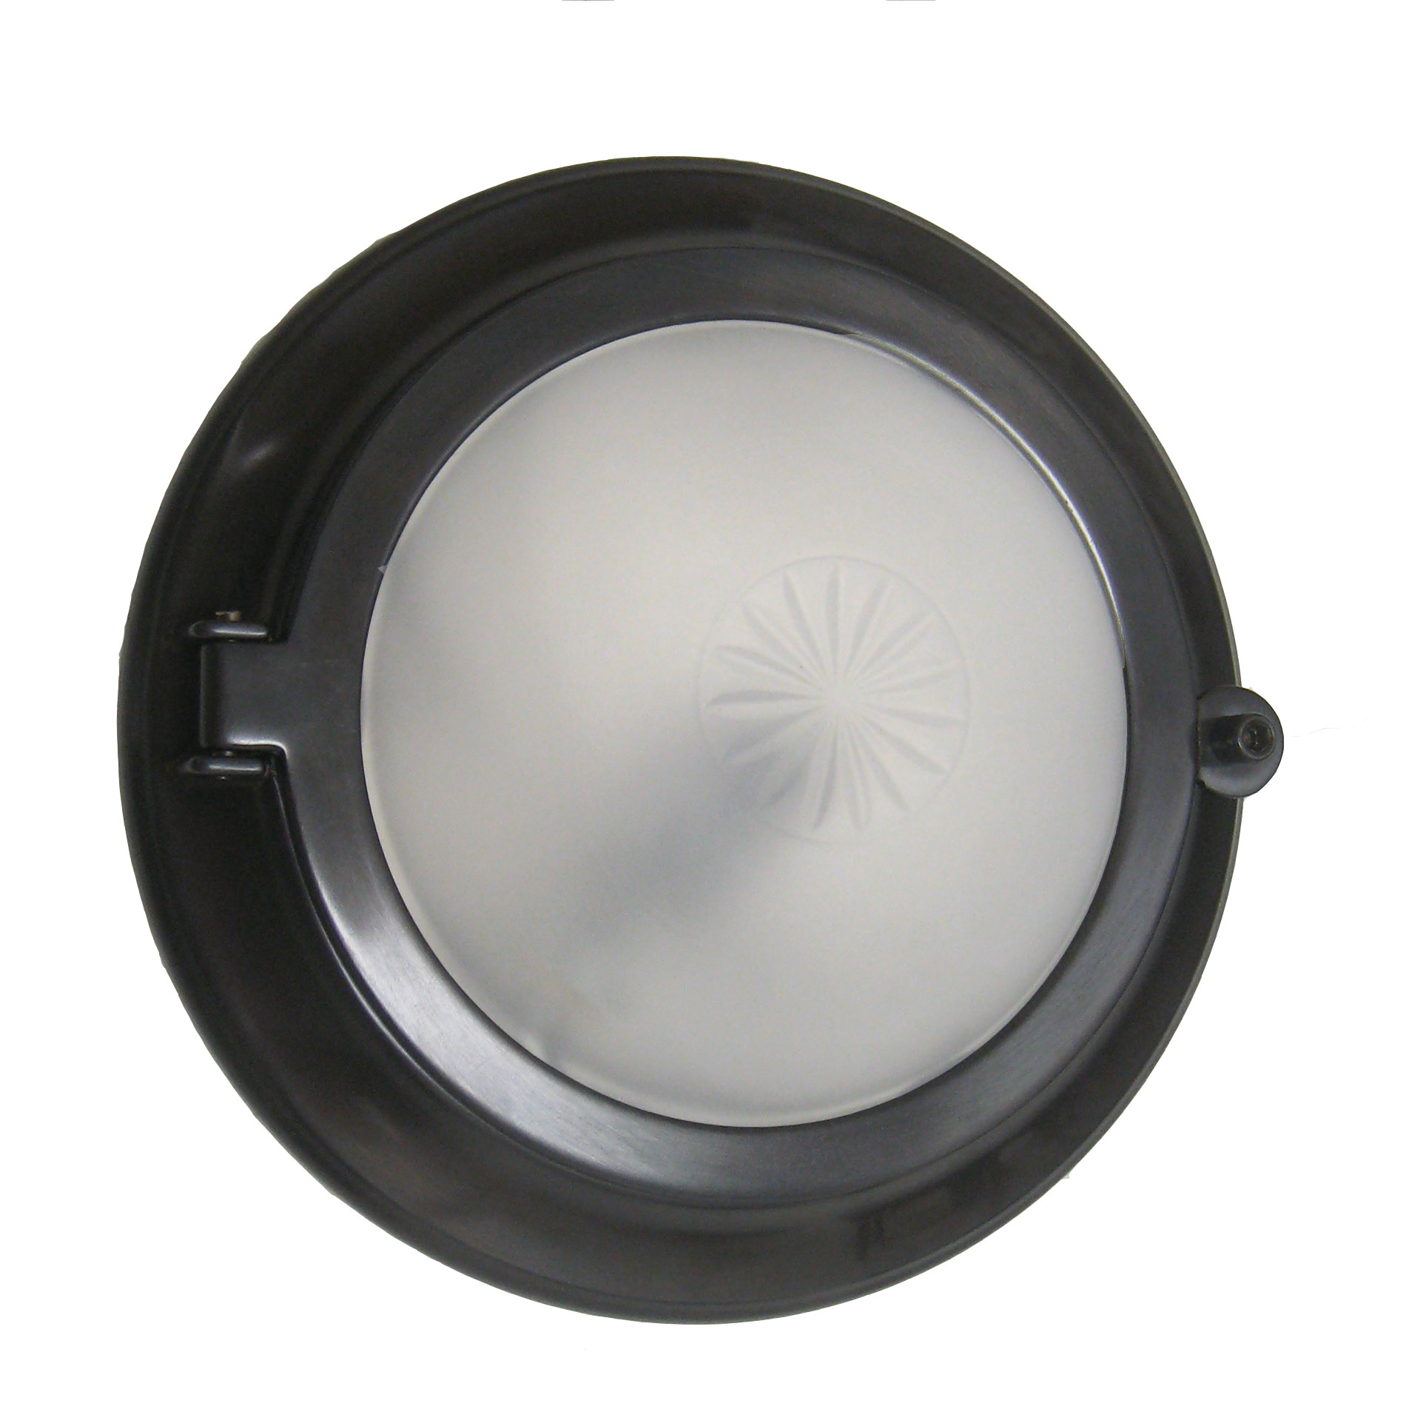 | 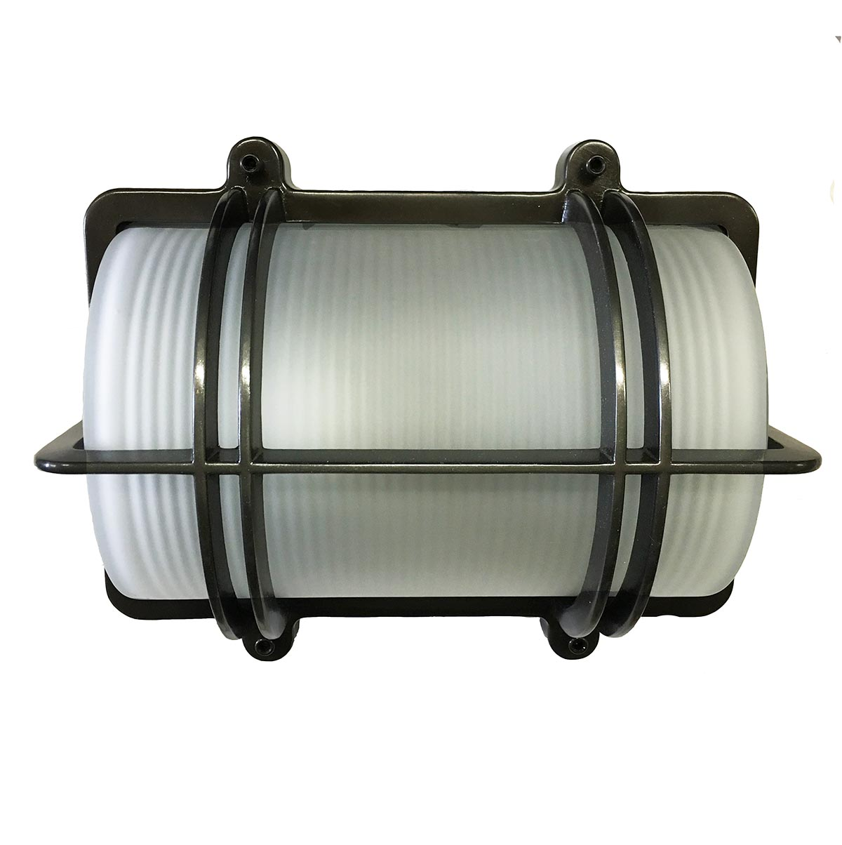

Antique Copper: Available Lacquered and Unlacquered (will Verdigris)

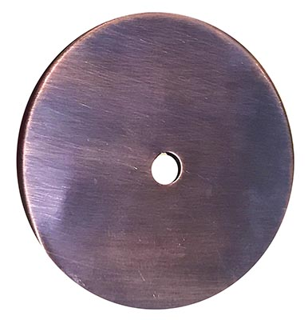 | 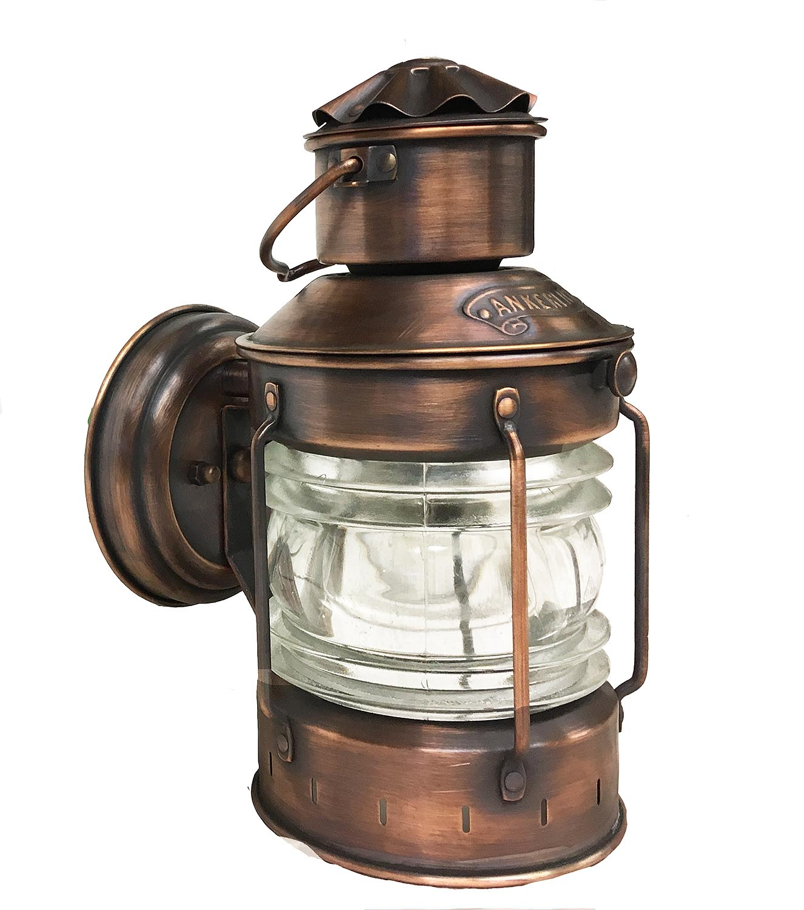

Polished Copper: Available Lacquered and Unlacquered (will Verdigris)

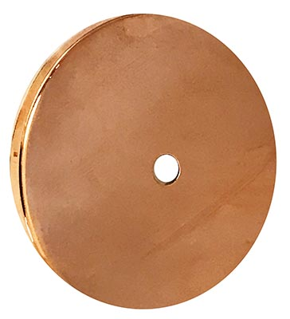 | 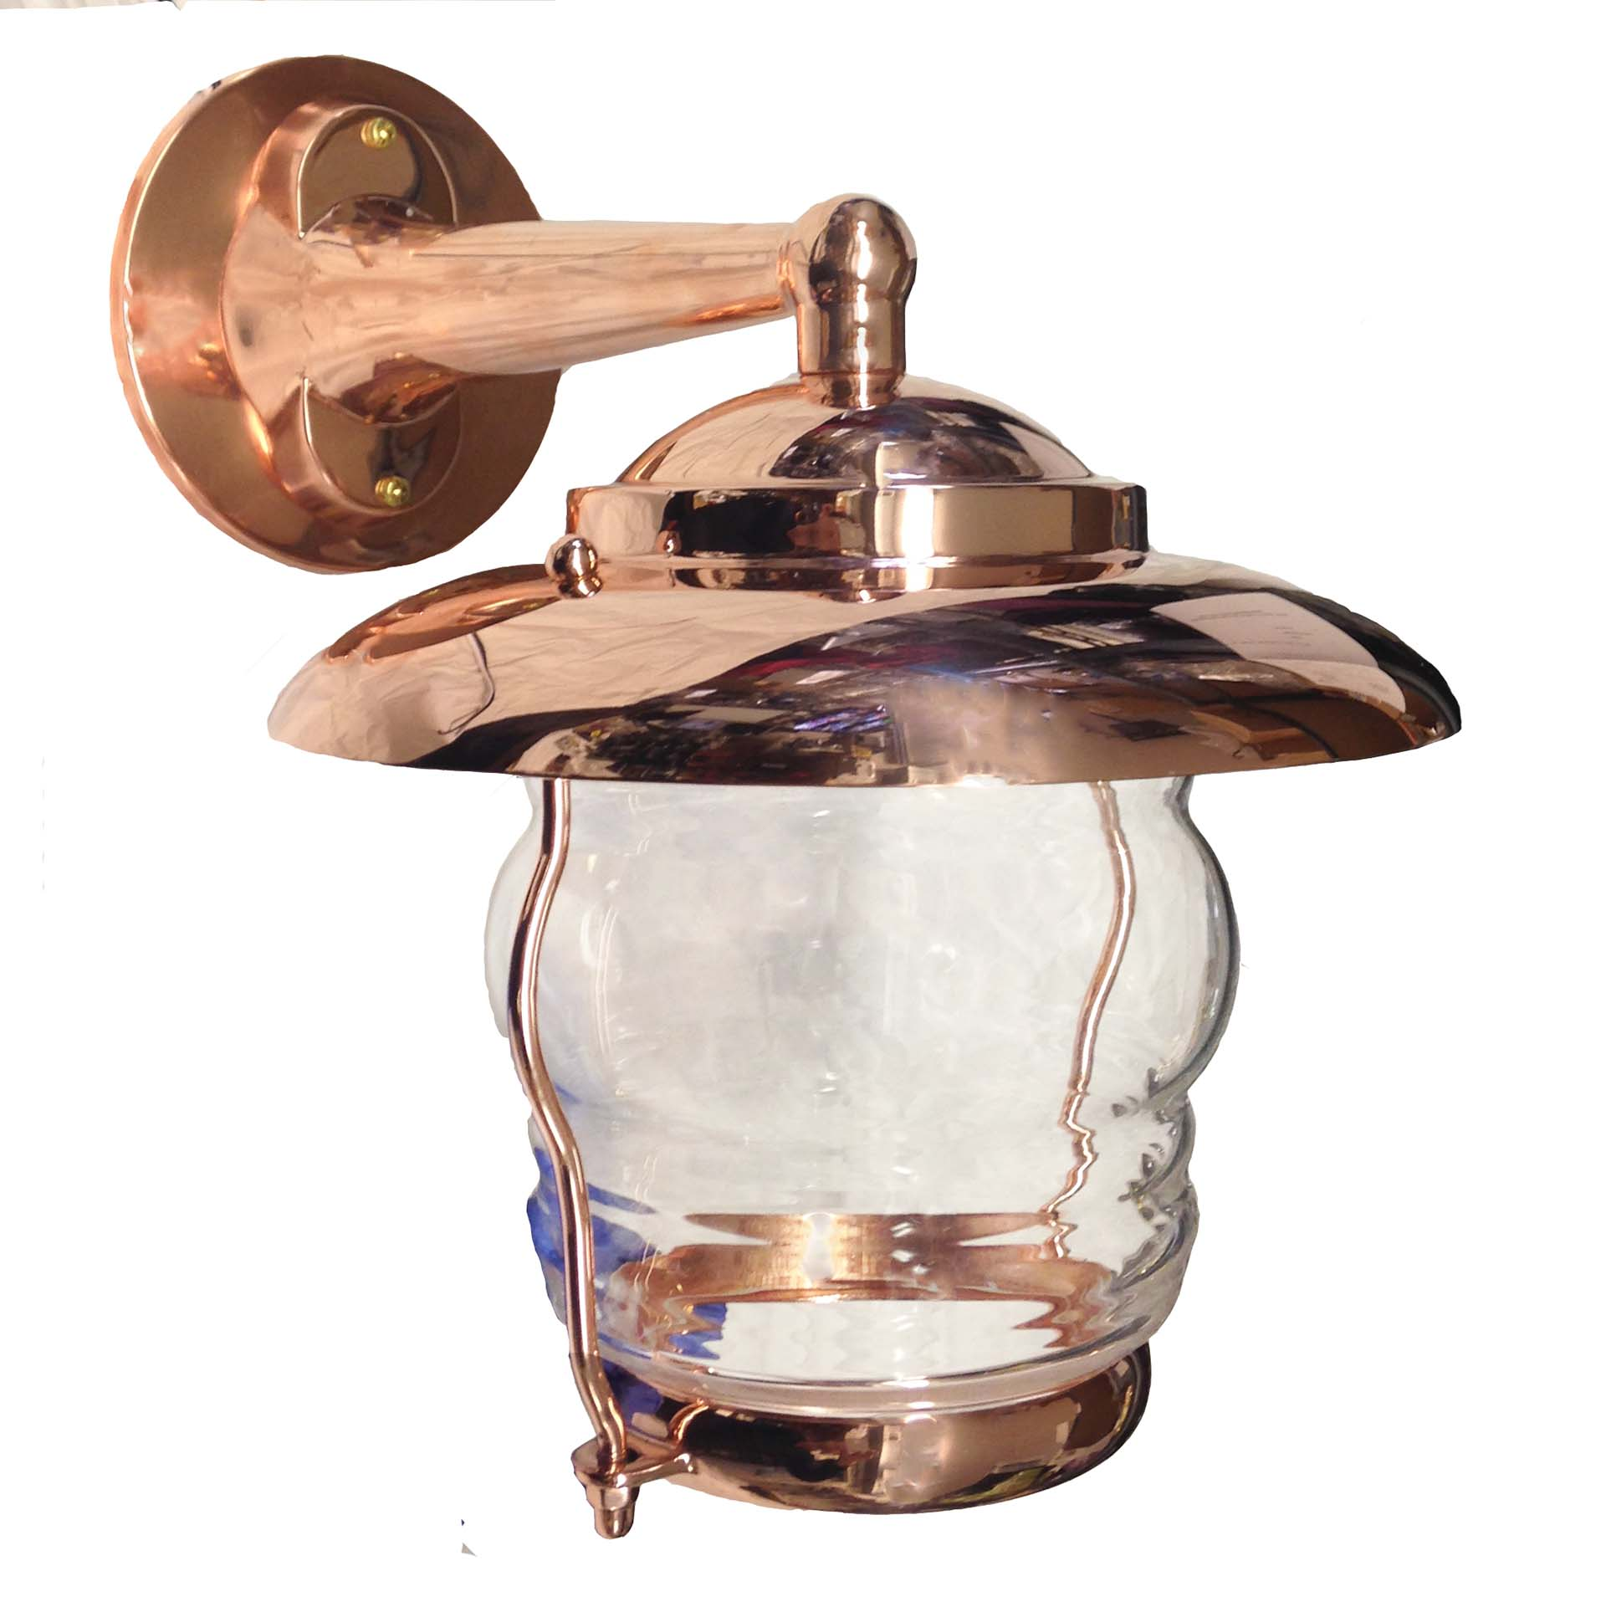

Satin Copper: Available Lacquered and Unlacquered (will Verdigris)

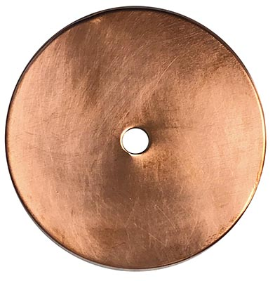 | 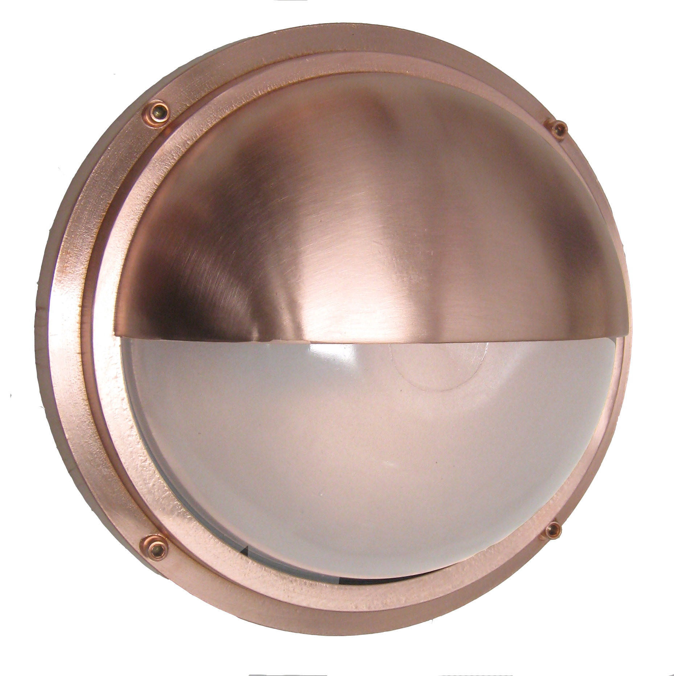 | 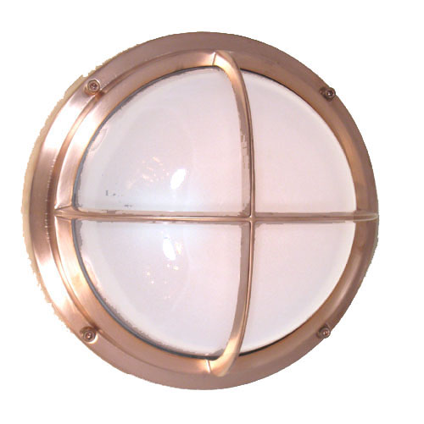 | 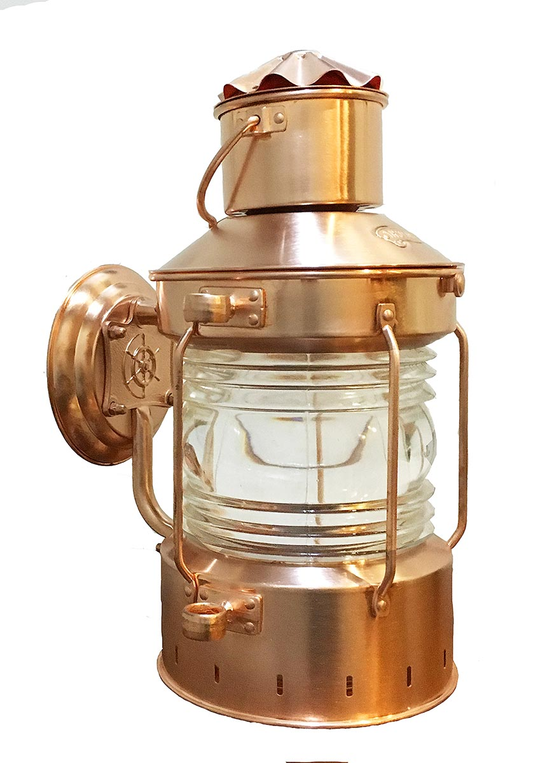
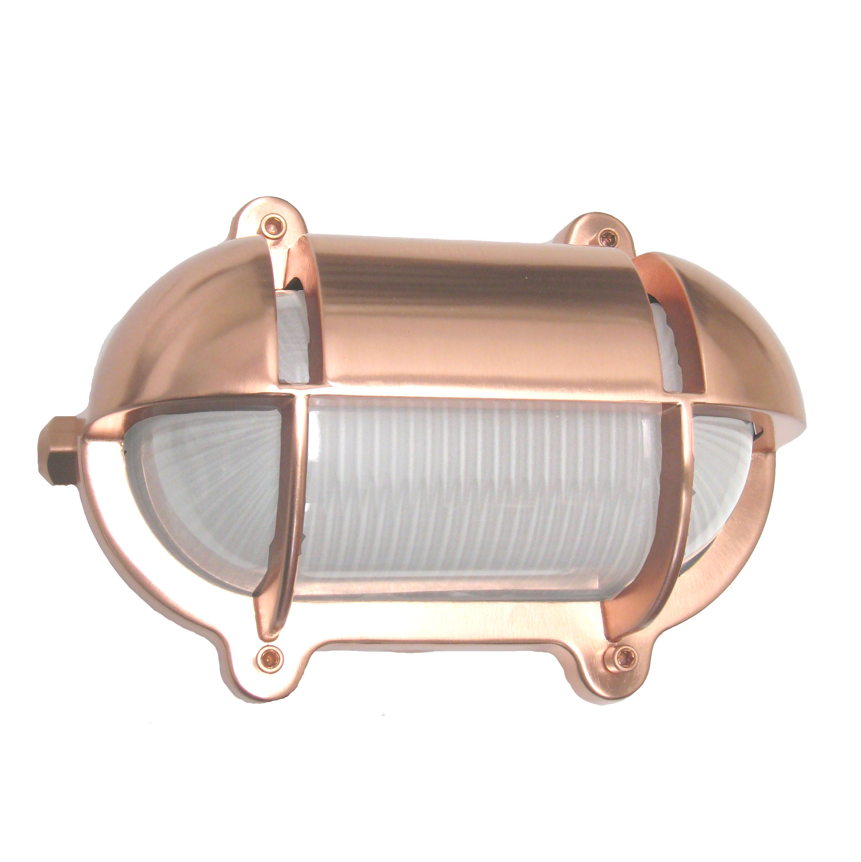

Verdigris: Made to replicate actual aging so finish will be inconsistent. Some places will be more ‘green’ and other more copper/bronze colored.

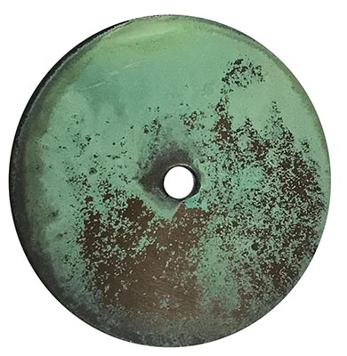 | 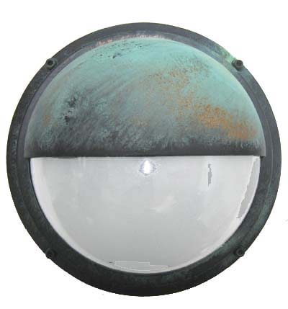

Metallic Tones:

Satin Chrome: The finish has a brushed look

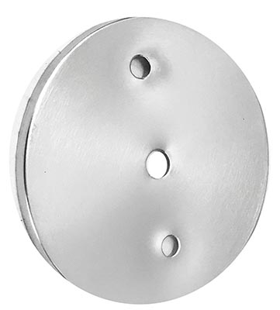

Antique Nickel: Intended to be a little inconsistent in color and may have some texture to it.

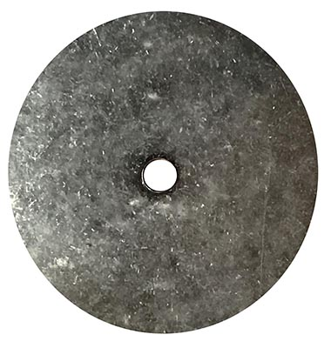 | 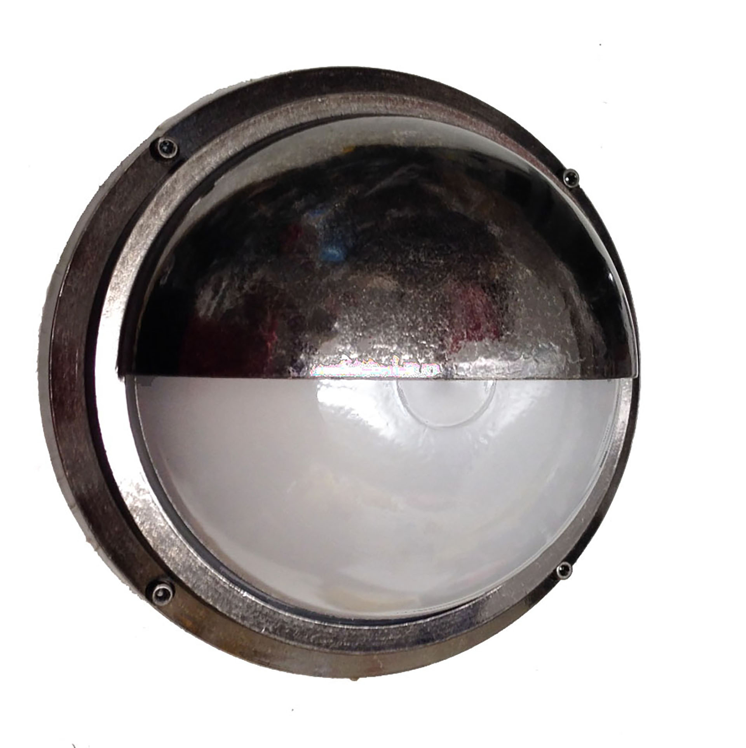 | 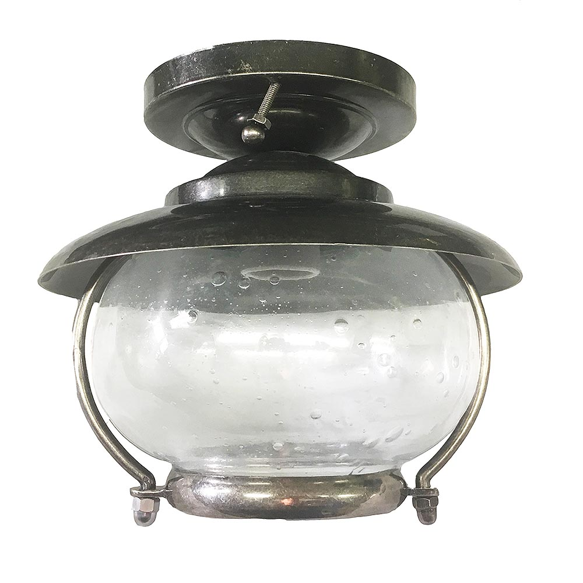

Polished Nickel: A bit more ‘softer’ / ‘warmer’ than chrome.

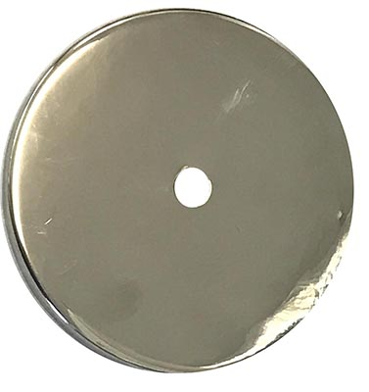 | 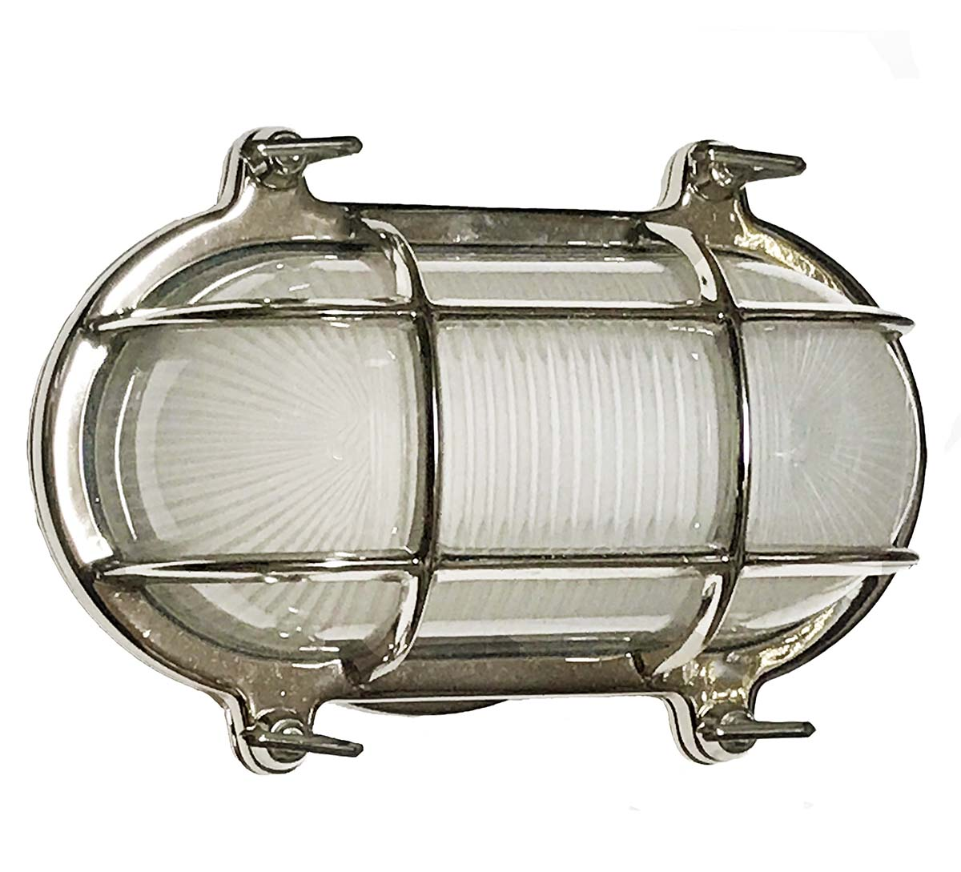

Satin Nickel: Preferred finish when matching Stainless Appliances/Hardware

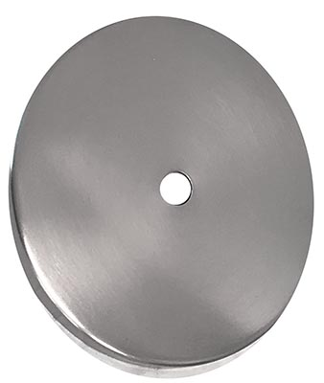 | 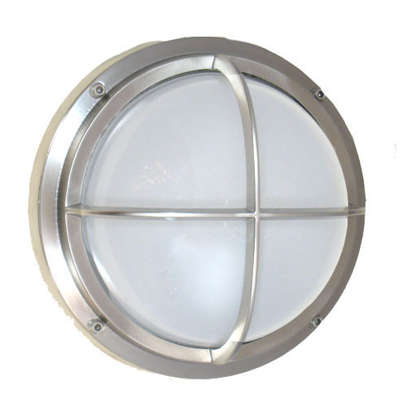 | 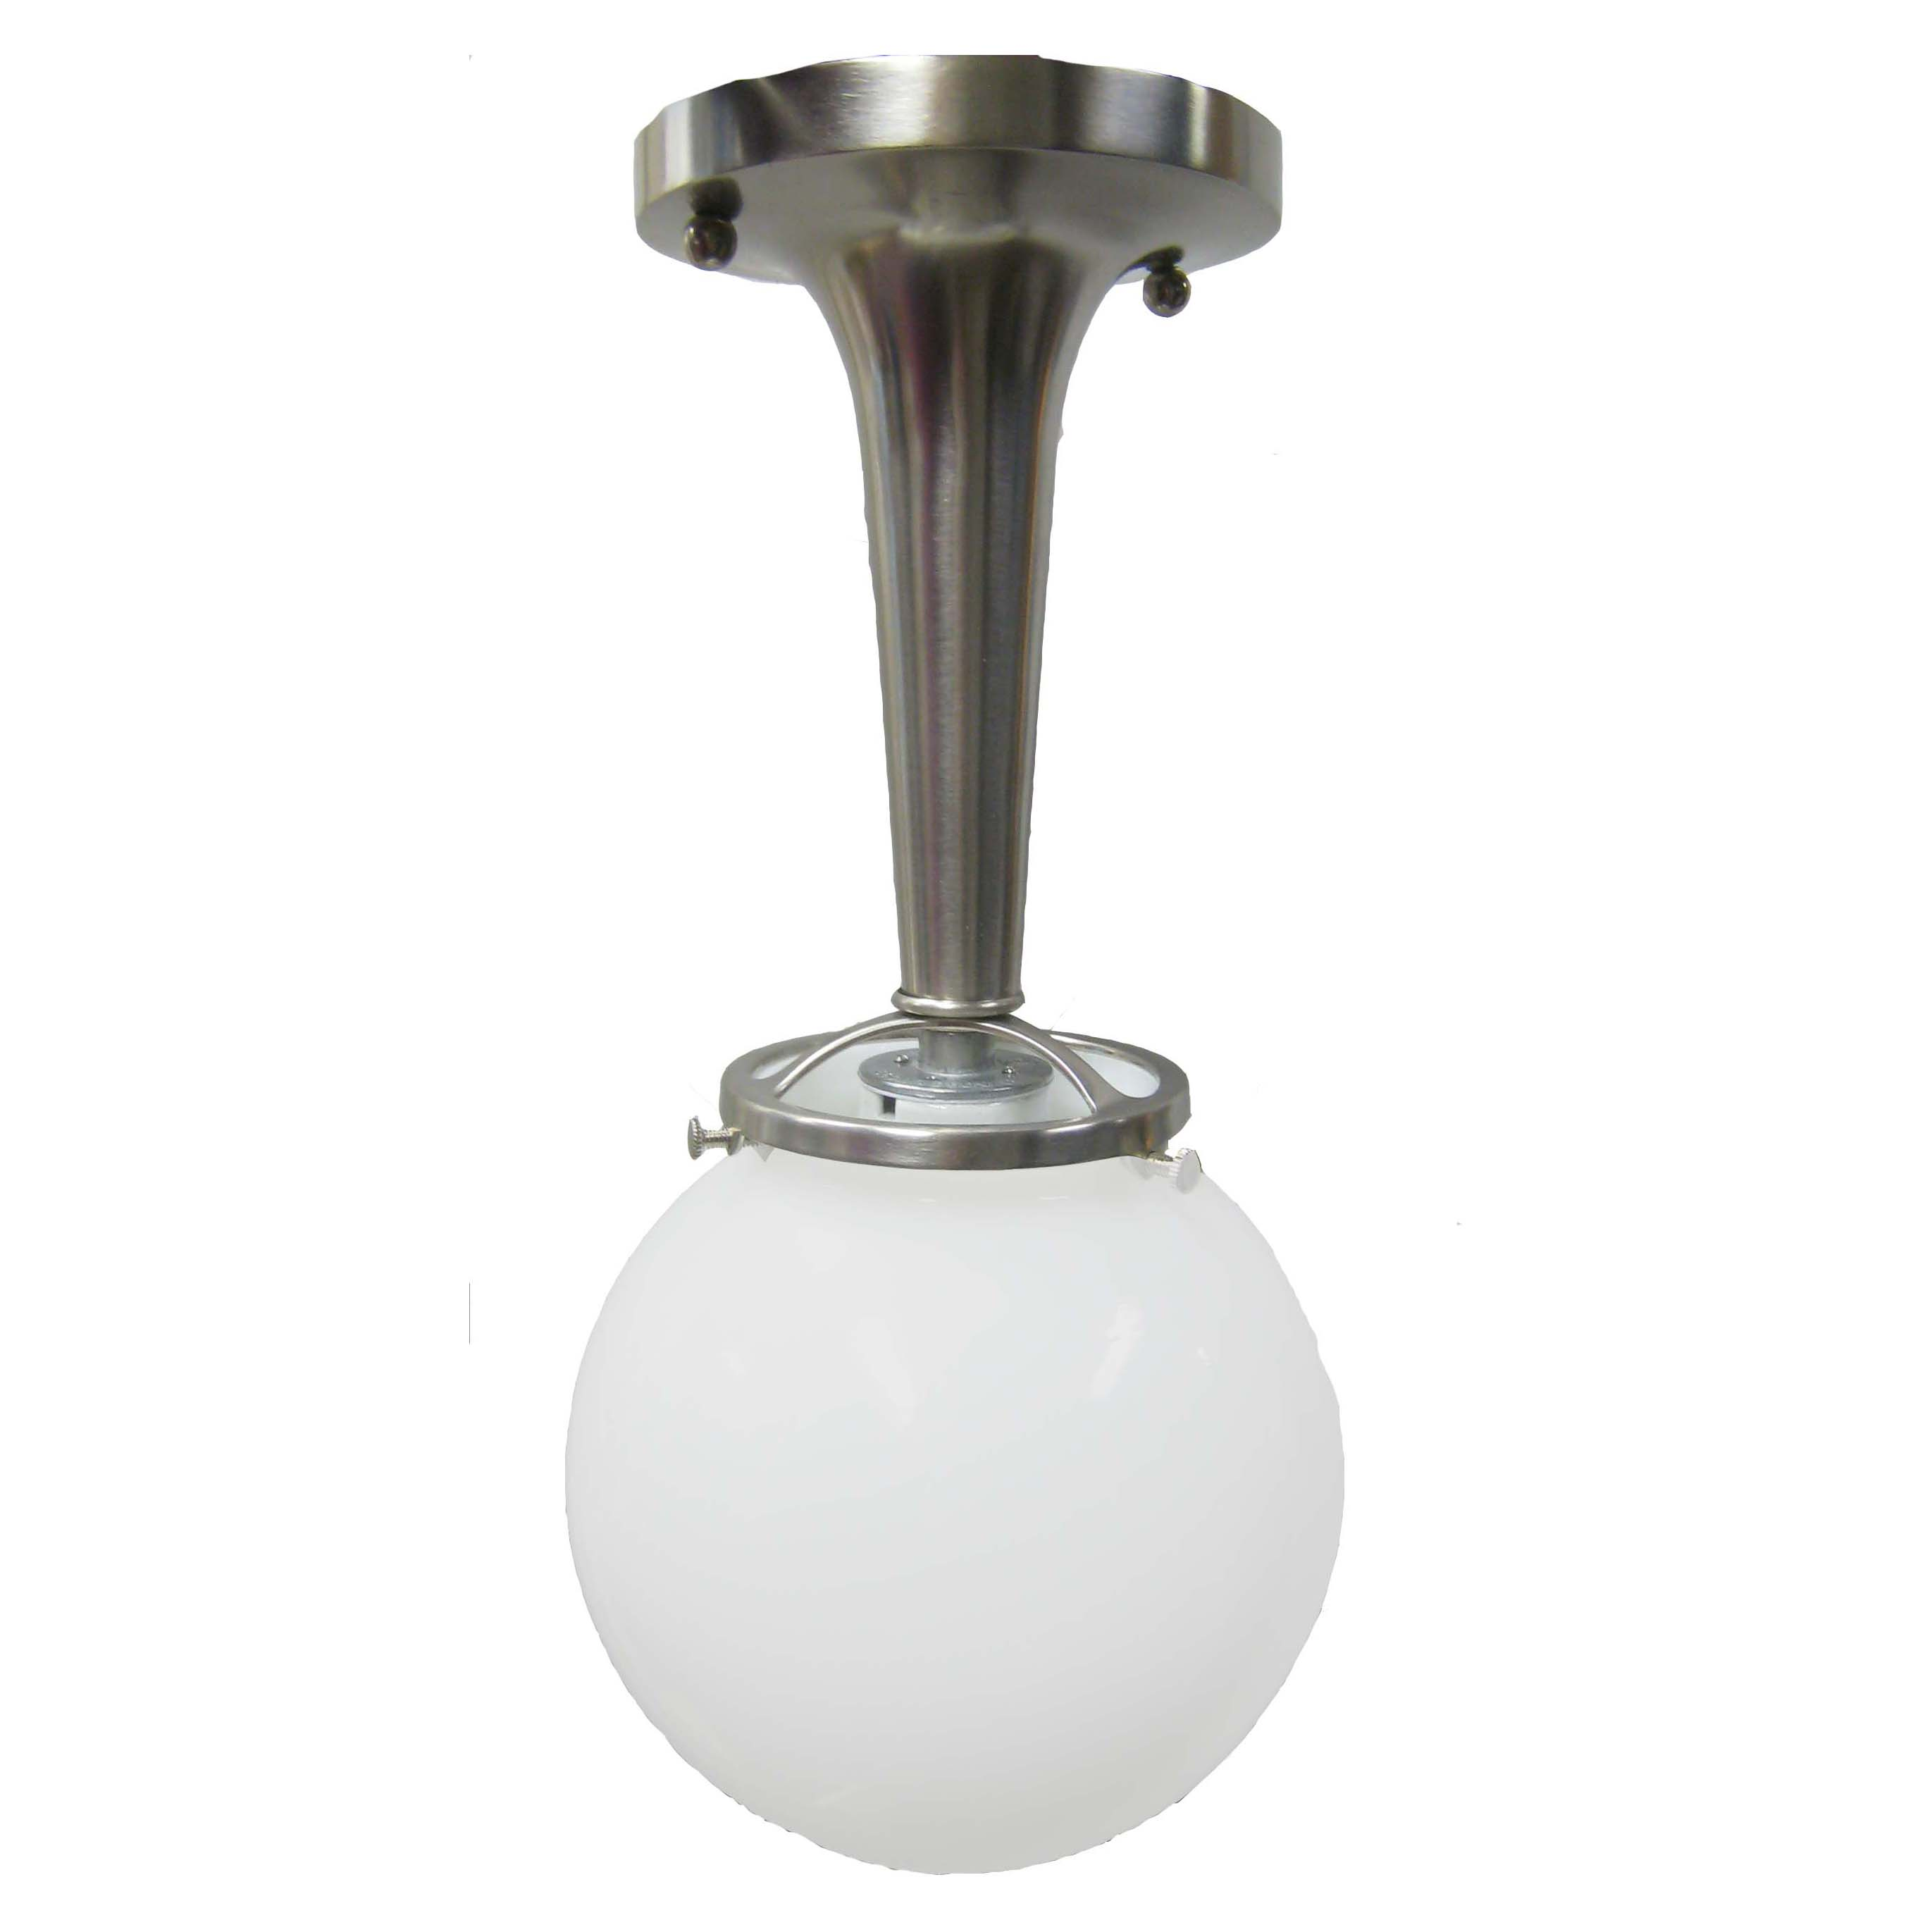 | 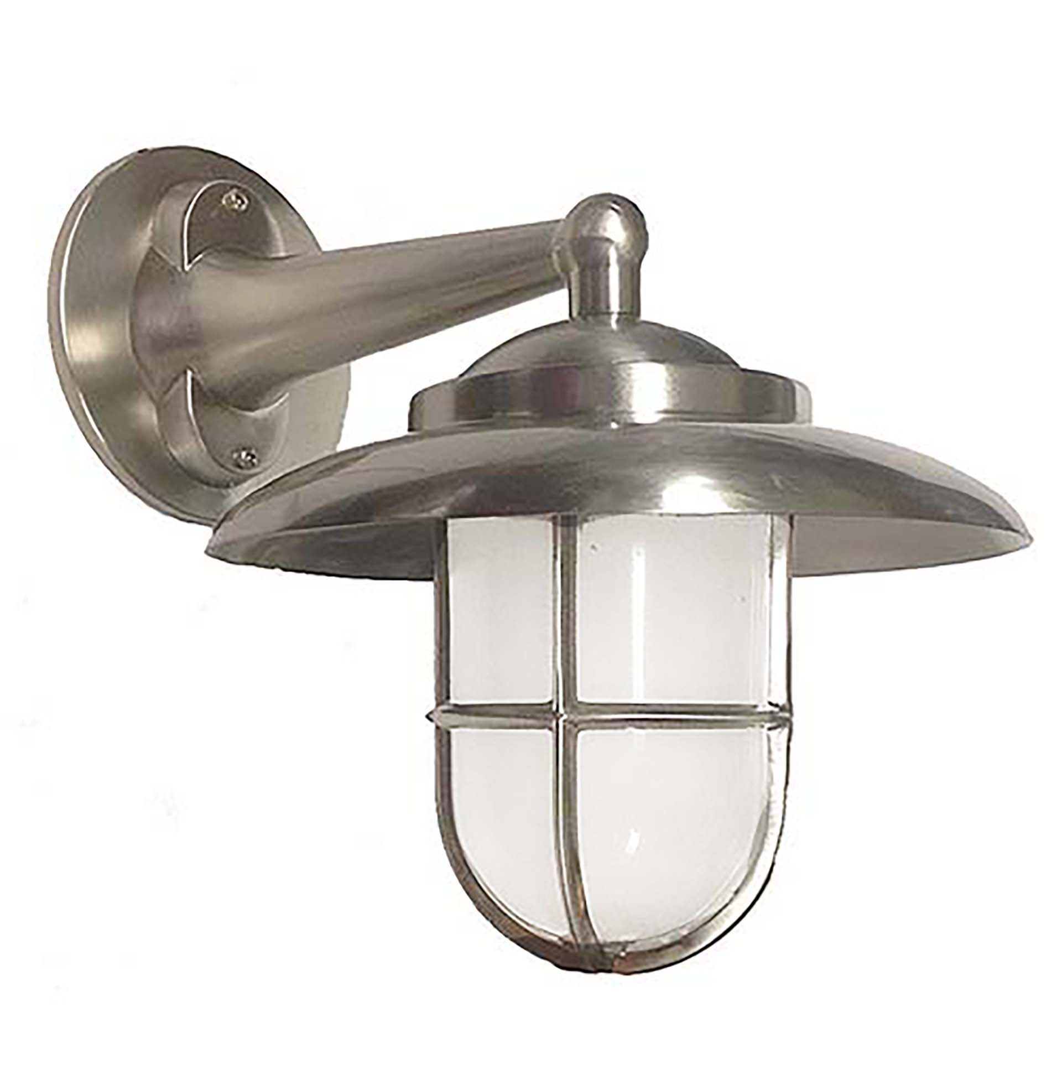
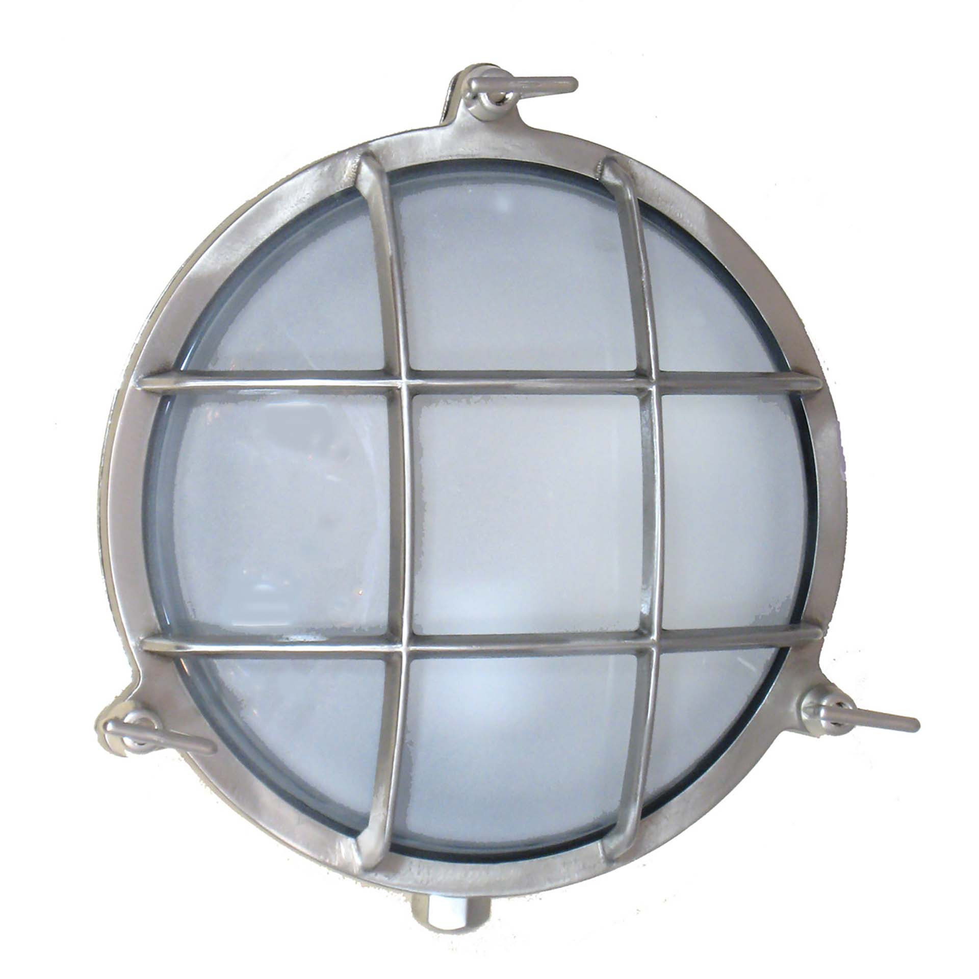 | 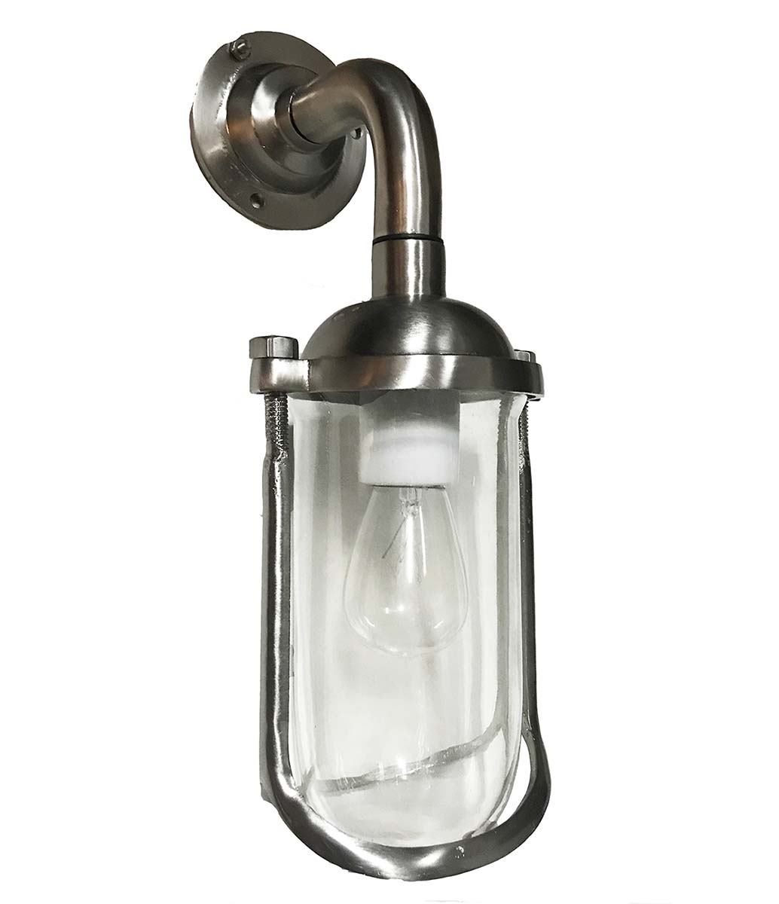 | 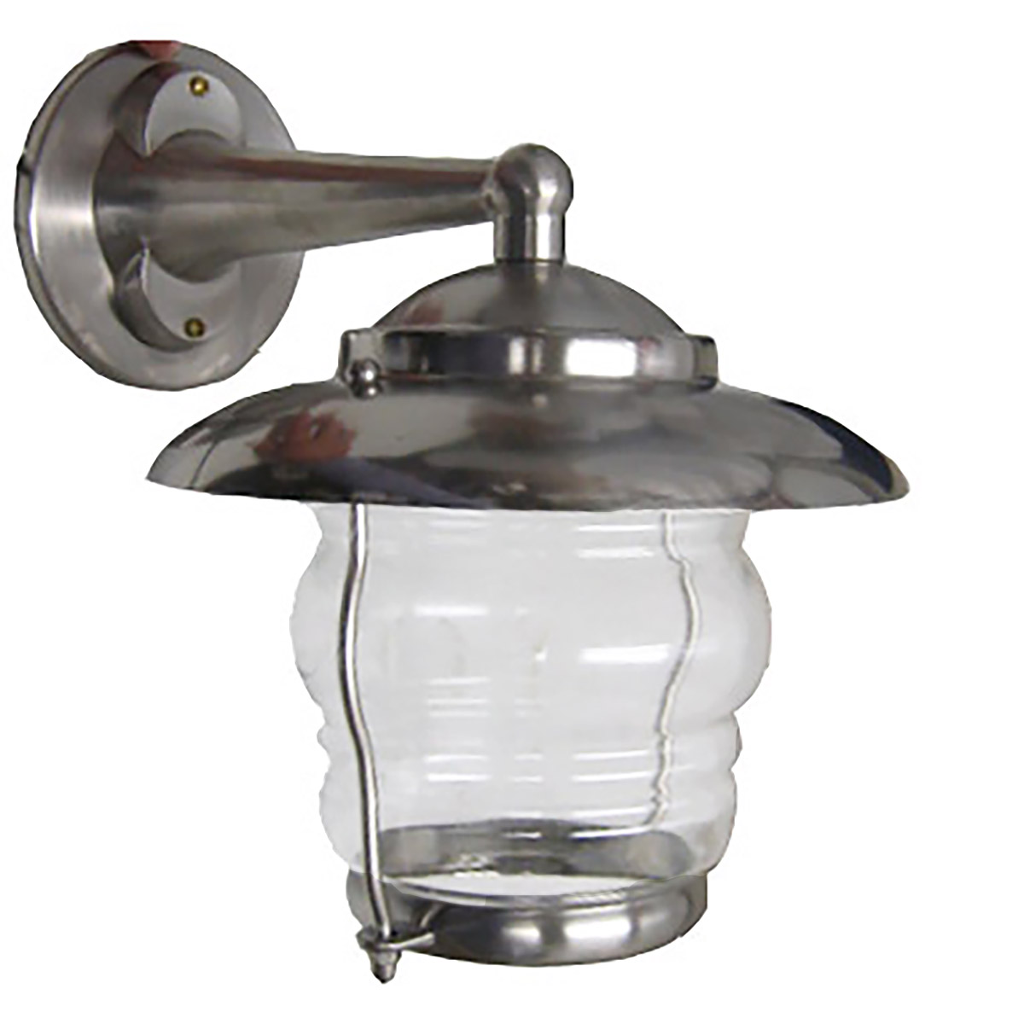

Pewter: A step darker than chrome and nickel; has a brushed look to it.

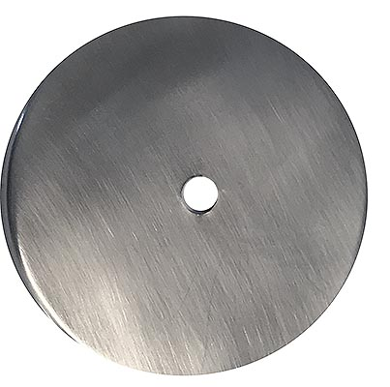 | 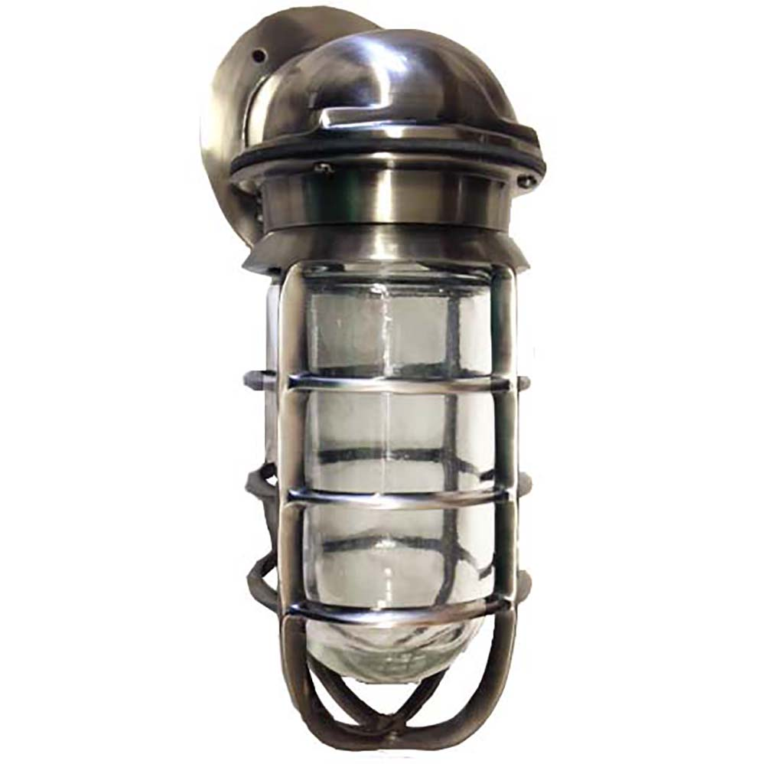

Custom Powder Coat: All colors and types available (Sample options below). Provide an RAL # for Matching.

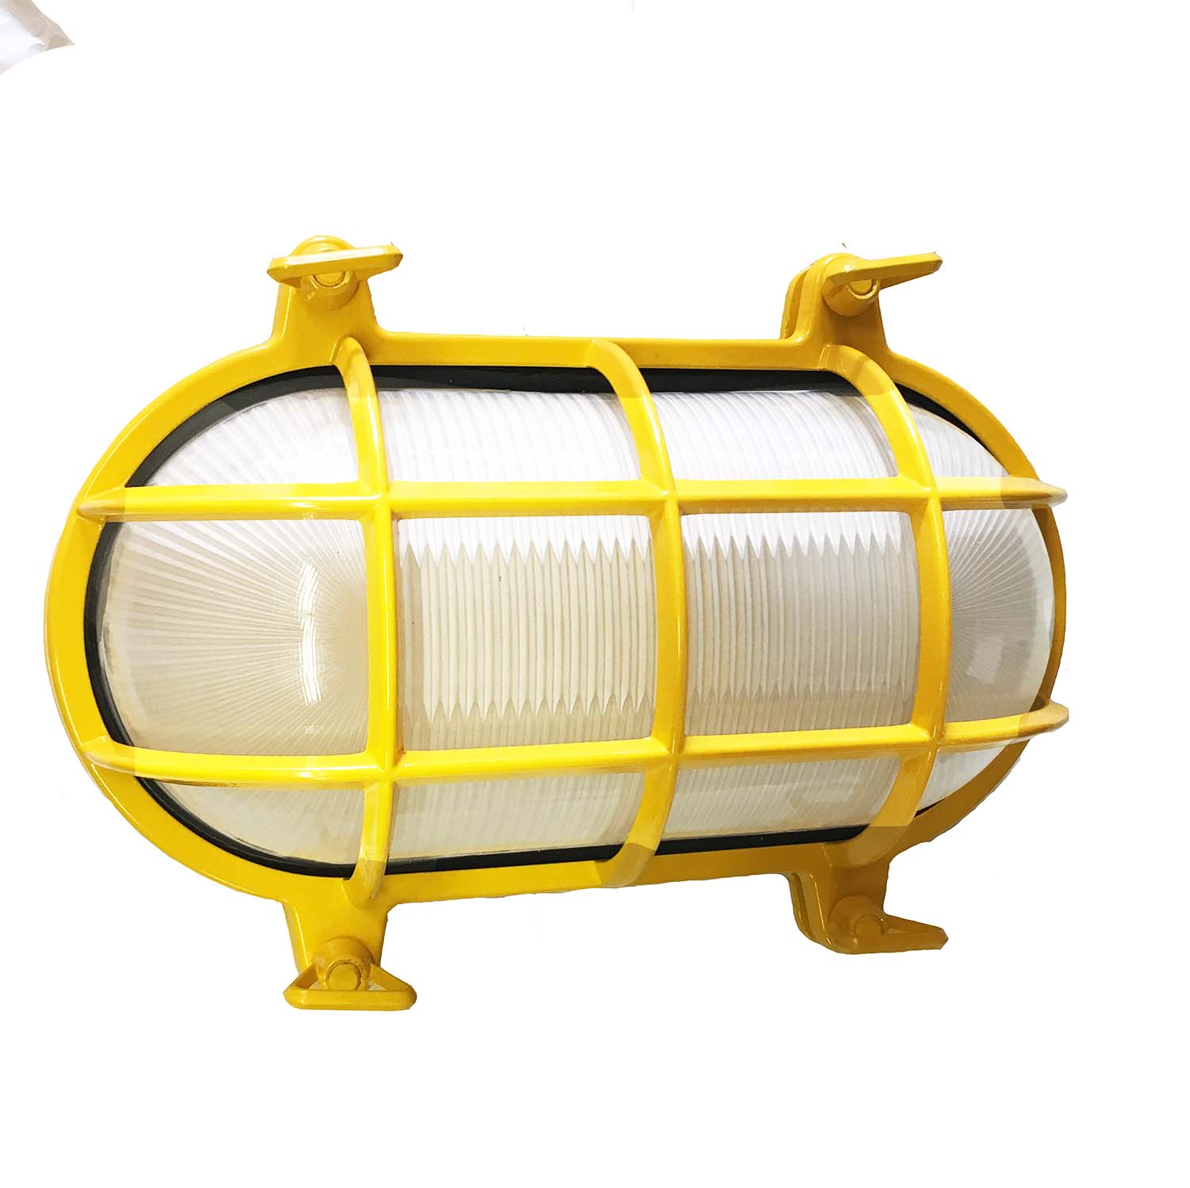  Yellow | 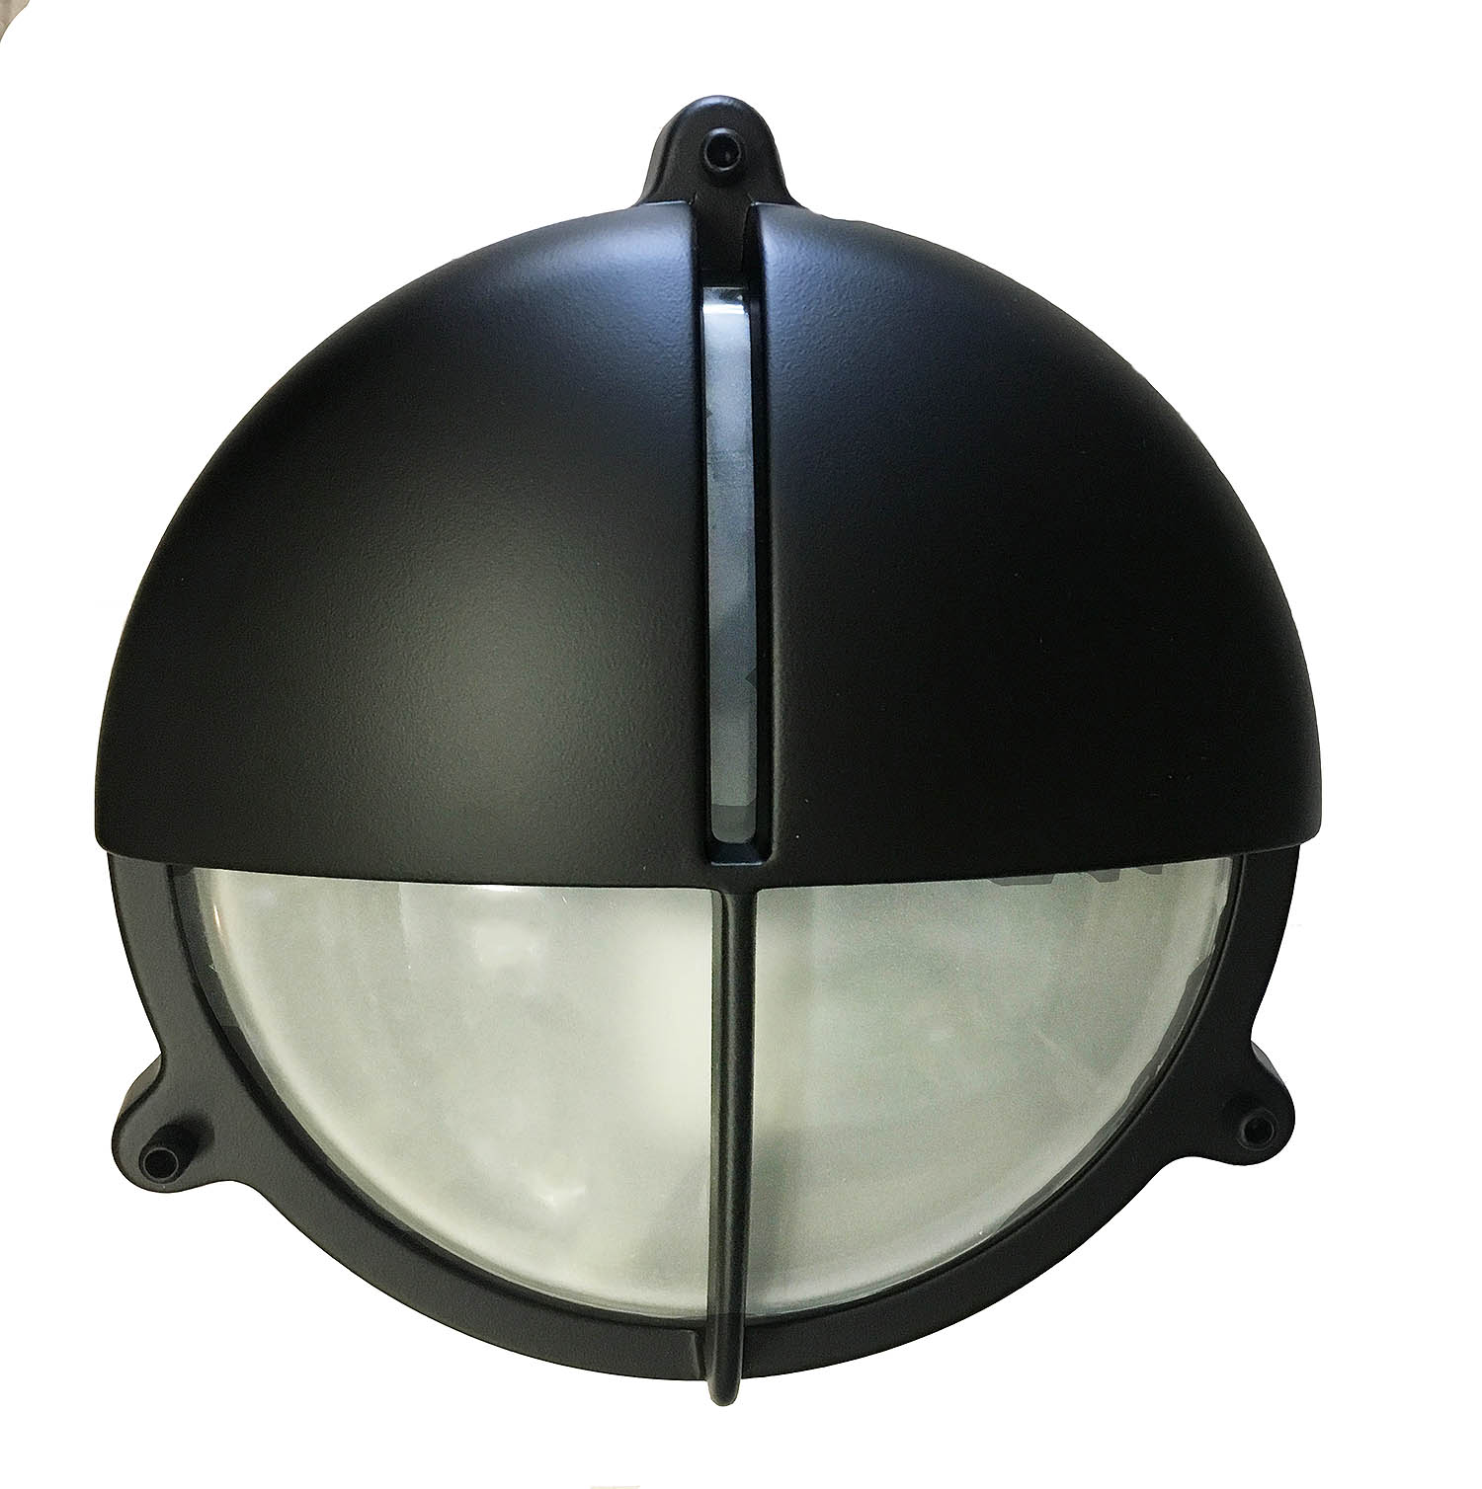  Matte Black | 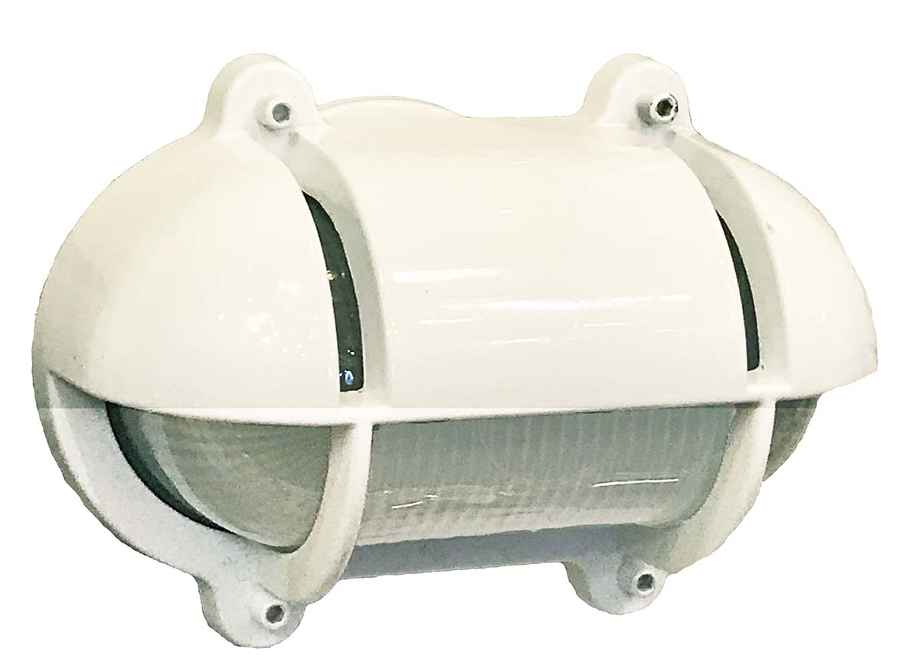  White | 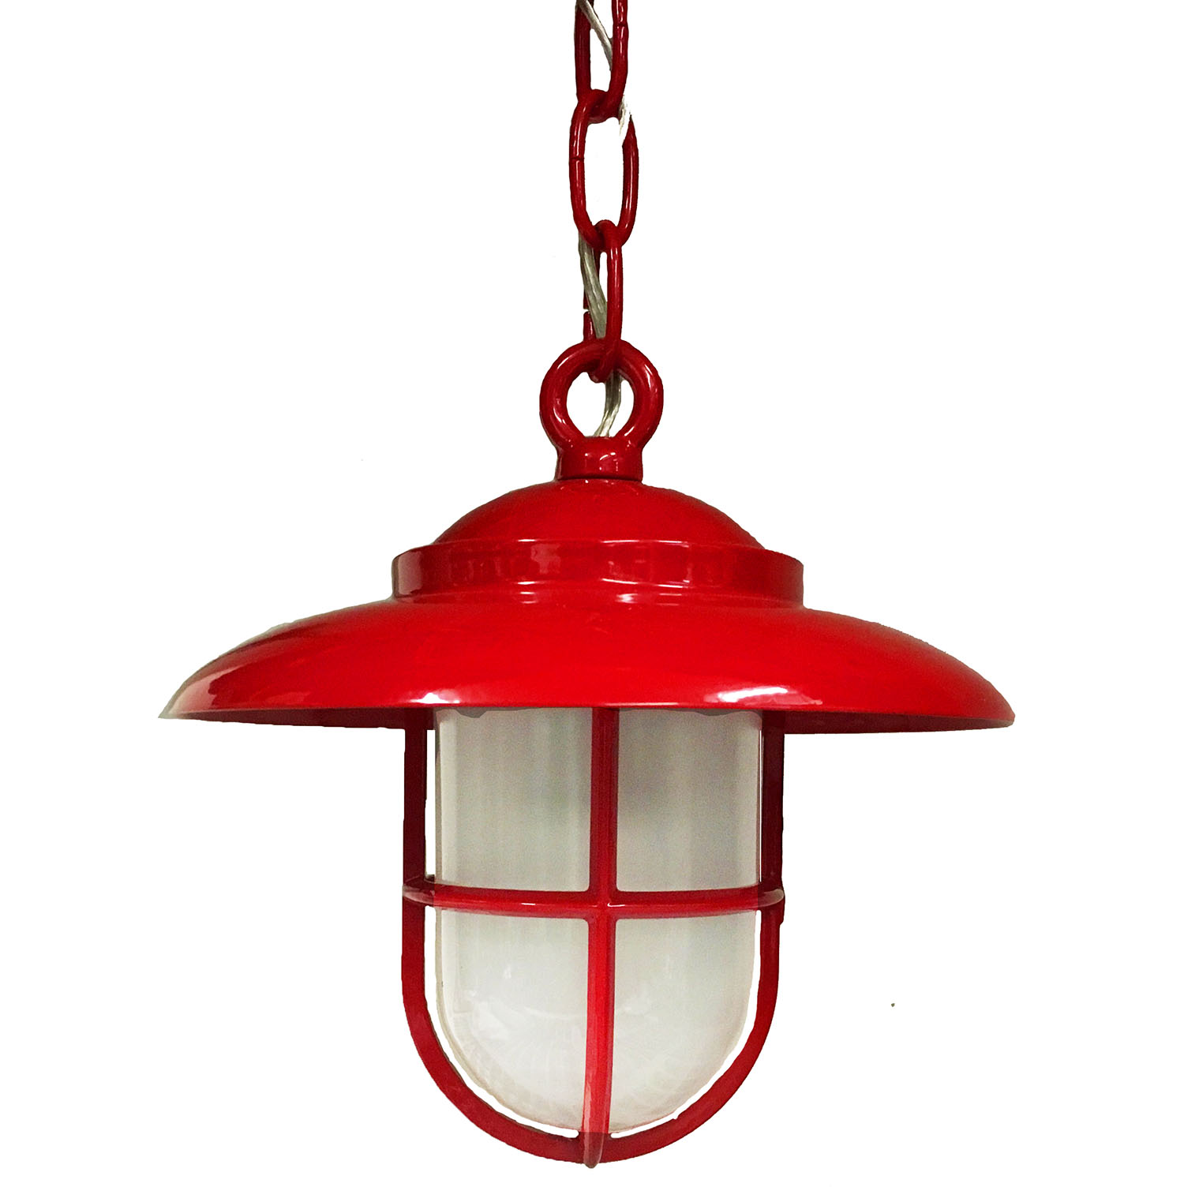  Red | 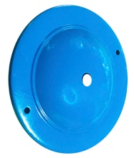  Blue

Important Custom Finish Information:
We recommend requesting actual finish samples as images are unable to capture the complexities of each finish and color. When in doubt, please contact us and we’re happy to send out samples. If you don’t see the finish you’re looking for, please ask. Unless otherwise specified, all are living finishes and all plating is over solid brass or bronze. All finishes will continue to darken over time and eventually verdigris. Special Orders are not refundable, have a minimum quantity and 4-8 weeks lead time. We do stock custom finish lights. Please inquire for custom lights available for immediate shipment (no minimums required).

Please remember that Powder coat colors will look different in person than on a computer screen.

